**SUPER PREDICTOR OF INDIAN PREMIER LEAGUE**

**A PROJECT REPORT**

**SUBMITTED IN PARTIAL FULFILMENT OF THE REQUIREMENTS**

**FOR THE**

**IBM HACK CHALLENGE 2021**

**BY**

**TEAM: Guerreros Técnicos**

**NARENDRA OMPRAKASH**

**VAISHNAVI V V**

**SHALINI A**

**ARAVINDA B**



**AUGUST 2021**

**TABLE OF CONTENTS**

1. INTRODUCTION 3
   1. OVERVIEW
   2. PURPOSE
2. LITERATURE SURVEY 4-5
   1. EXISTING SYSTEM
   2. PROPOSED SYSTEM
3. THEORITICAL ANALYSIS 6-7
   1. BLOCK DIAGRAM
   2. HARDWARE/SOFTWARE DESIGN
4. EXPERIMENTAL INVESTIGATIONS 8

5 FLOWCHART 9

6. RESULT 10-24

7. ADVANTAGES AND DISDVANTAGES 24-25

8. APPLICATIONS 25-27

9. CONCLUSION 27

10 FUTURE SCOPE 27

11 BIBILIOGRAPHY 28

APPENDIX 28-32

A. SOURCE CODE

1. **INTRODUCTION**

**1.1 Overview**

IPL has been a trend since it had begun, setting an extremely sustainable future. The game has culminated to attract a wide range of audience exclusive of the age groups.

Data Analytics has been a part of sports entertainment for a long time. In cricket, it is common to predict the score from the team’s previous matches or any other instincts.

The Super IPL Score Predictor focuses on performing analysis on IPL statistics and building a dashboard based on the team’s performances. This is followed by the prediction of first innings score and a chatbot as an IPL guide for beginners. Datasets are pre-processed and two machine learning algorithms-Linear Regression and Random Forest are used to measure the accuracy and find the best one to predict the first innings score.

**1.2 Purpose**

Creating a legendary milestone in the world of a sport like cricket, the BCCI introduced Indian Premier League (IPL). As the volume of cricket enthusiasts across the globe increases, the curiosity on prediction of the future matches led to creation of many websites like Dream11, IPL fantasy league etc. IPL predictions can be right or wrong.

The main objective of our project is to analyse the IPL statistics of various matches and teams. Dashboards are created for individual teams to provide an insight of their performance from the beginning of IPL. Future scores pertaining to a match are predicted.

The project, developed as a web application, will satisfy the needs of a cricket expert as well as a beginner.

**2. LITERATURE SURVEY**

**2.1 Existing problem**

Indian premier league is an international extravaganza that has close finishes, innumerable hat-tricks, Super-Over drama, tumbling records and death-defying fielding making the cash-rich event an interesting one. Analysis on this tournament can help in acquiring insights for commercial and entertainment purposes. Data is produced in humongous amount and using it efficiently will provide an edge over the competitors. Most of the existing solutions available in the market are not deployed as commercial product and are in testing phase. Broadcasters are responsible for presenting the insights obtained by the existing solutions in an understandable form to their users. Common public who don't have domain knowledge about running the notebooks will find it difficult to understand the fruit of existing solutions. In addition, the strengths and weakness of each team are not analysed in most of the existing solutions. The above demerits are solved in our product.

**2.2 Proposed solution**

IPL predictor provides useful insights obtained by performing exploratory and predictive analysis. The product serves both commercial and entertainment purpose. The product is user friendly where the insights are presented in comprehensible manner and the user can navigate freely through the pages, improving the reliability of the product. Features present in the product will give the user a better knowledge about IPL and features incorporated are:

**1) Analysis about overview of IPL**

Set of eleven questions were framed in such a way that it covers all the aspects of the game. The answers for the questions are found by performing exploratory analysis on the dataset containing attributes like(toss winner, batting team, bowling toss, match winner and so on) with the help of SQL queries and python. The insights obtained are visualized in the form of graph using Cognos feature provided by IBM.

**2) Team wise Analysis**

Team wise analysis provides insights about the strengths and weaknesses of the team. The analysis includes happenings in different phases of game, highest run scorer and highest wicket taker and so on. The happenings in different phases of game (powerplay, middle over and death-over) can help the team management and opponents to strategize their game plan , and the users an idea about the proceedings of the game. The analysis is done in IBM Watson and insights obtained are visualized using IBM Cognos.

**3) Teams performance in particular season**

The feature gives an idea to the user about the proceedings of the game in a particular year. Data mining is performed to fetch results relevant to the particular team in the year prescribed by the future.

**4) Predicting first Innings Score**

An important type of analysis in data analytics is predictive analysis. It provides insights about what is going to happen in the near future. The first innings score is predicted by a model trained using machine learning algorithms. Various ML algorithms like Random forest were applied and linear regression was found to be the best, topping the accuracy score and hence the model is trained with linear regression to predict the first inning score.

**5) Chatbot**

Chatbot is created to answer minimal queries asked by the users. The chatbot is created using Watson assistant by adding relevant dialog and entities that can handle irrelevant questions and answer relevant questions. The chatbot can solve queries related to the structure of IPL, format of the game and so on.

The above are features of the product that add value to the product and the user-friendly interface improves the reliability of the product.

**3. THEORITICAL ANALYSIS**

**3.1 Block Diagram**

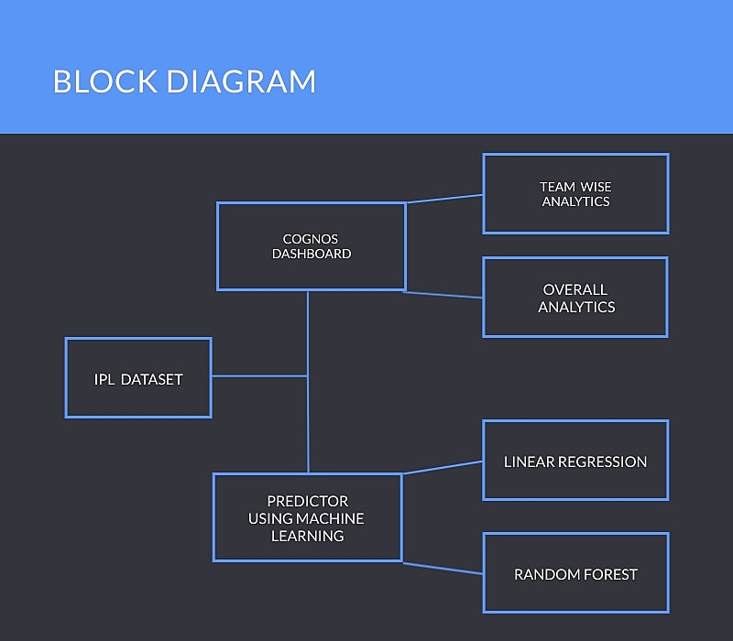

**3.2 Hardware/Software Designing**

**Hardware Requirements:**

* Windows/Linux/Mac OS
* Memory (RAM): Minimum 1 GB; Recommended 4 GB or above
* Ethernet connection (LAN) OR a wireless adapter (Wi-Fi)

**Software Requirements:**

* IBM Watson Studio
* IBM Watson Assistant
* Cognos Dashboard
* Flask Framework
* HTML
* CSS
* Javascript

**4. EXPERIMENTAL INVESTIGATIONS**

Extensive study about the topic was performed and various methodologies used in this domain were found. Predominantly there were two types of analysis: exploratory and predictive. Exploratory analysis visualizes events that have occurred in the past and provides meaningful insights that can be used for decision making.

<https://www.analyticsvidhya.com/blog/2021/05/the-data-science-behind-ipl/> article explains the importance of data science in IPL and talks about the interesting facts being produced as a biproduct of analysis.

<https://www.kaggle.com/patrickb1912/ipl-complete-dataset-20082020> article explains the structure of the data and provides statistical insights of the metadata (i.e mean, mode, average and so on)

<https://towardsdatascience.com/exploratory-data-analysis-of-ipl-matches-part-1-c3555b15edbb> article gives an idea about how to go about data cleaning and preparation. In any data science lifecycle, data cleaning and data preparation are given utmost importance that can prevent various mishaps that tends to happen in the future.

<https://towardsdatascience.com/analysing-ipl-data-to-begin-data-analytics-with-python-5d2f610126a> article explores the answers of basic questions that gives an idea about the working of IPL.

<https://medium.com/analytics-vidhya/how-to-implement-an-end-to-end-machine-learning-project-using-flask-ipl-score-prediction-9957795f1159> article gives an idea of how to go about predictive analysis using linear regression

Using the above resources, a prototype for the product was developed.

**5. FLOWCHART**

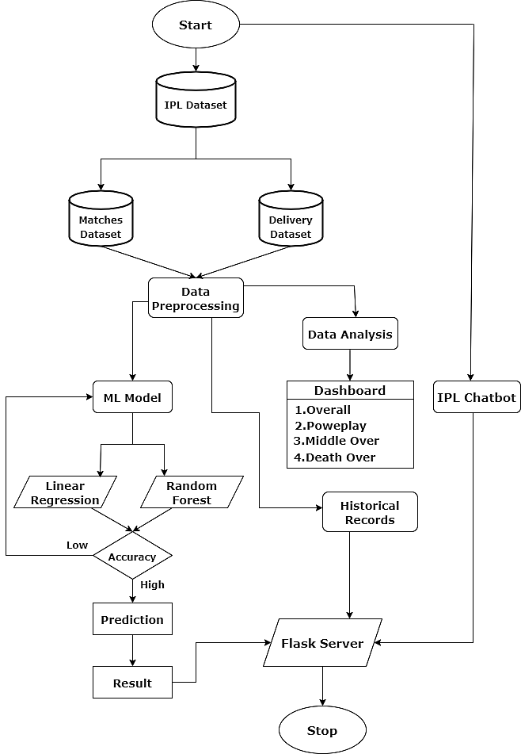

**6. RESULT**

An user-interface was developed on Flask server:

* To display the historical records of a team in a particular year with details like opponent team, the first innings team, the second innings team, Man of the Match (MoM), venue of play, date of play and the margin of victory (by wickets/by runs). The green card indicated a victory and contrastly the red card indicated a loss.

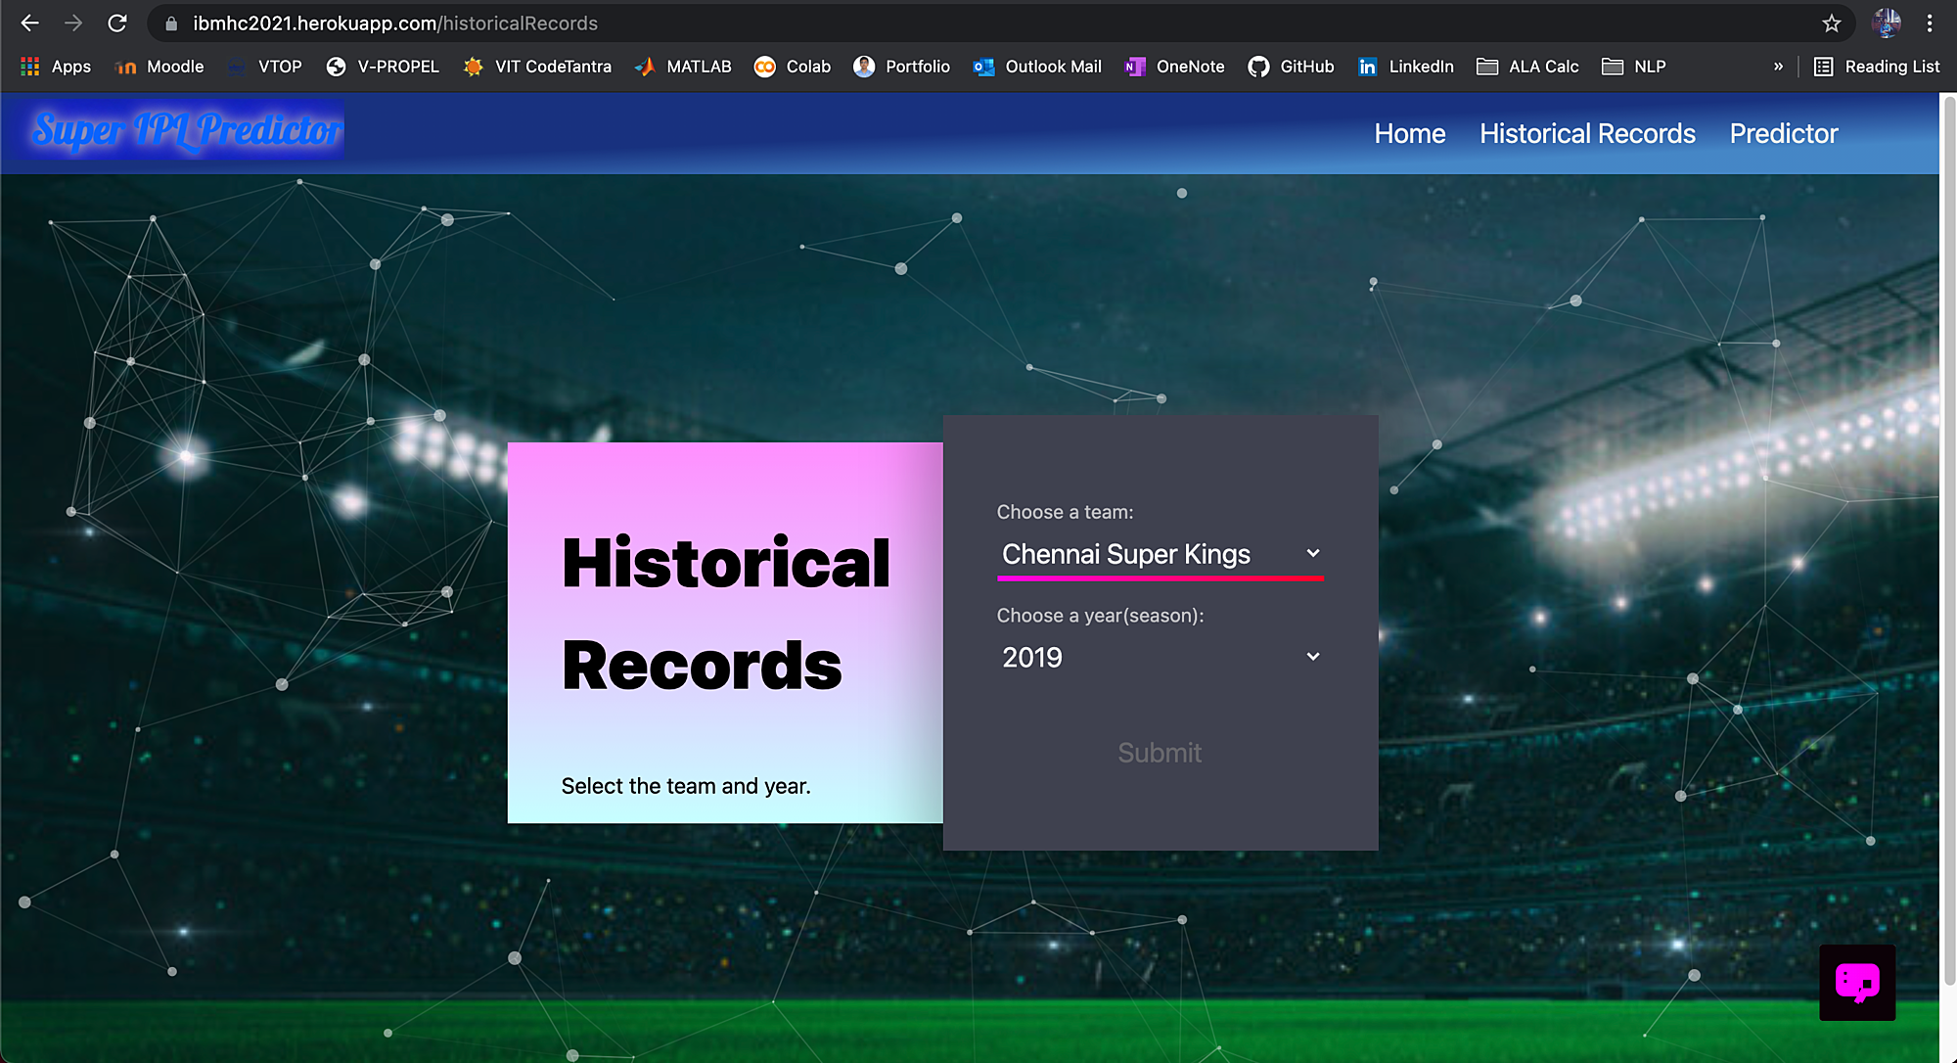

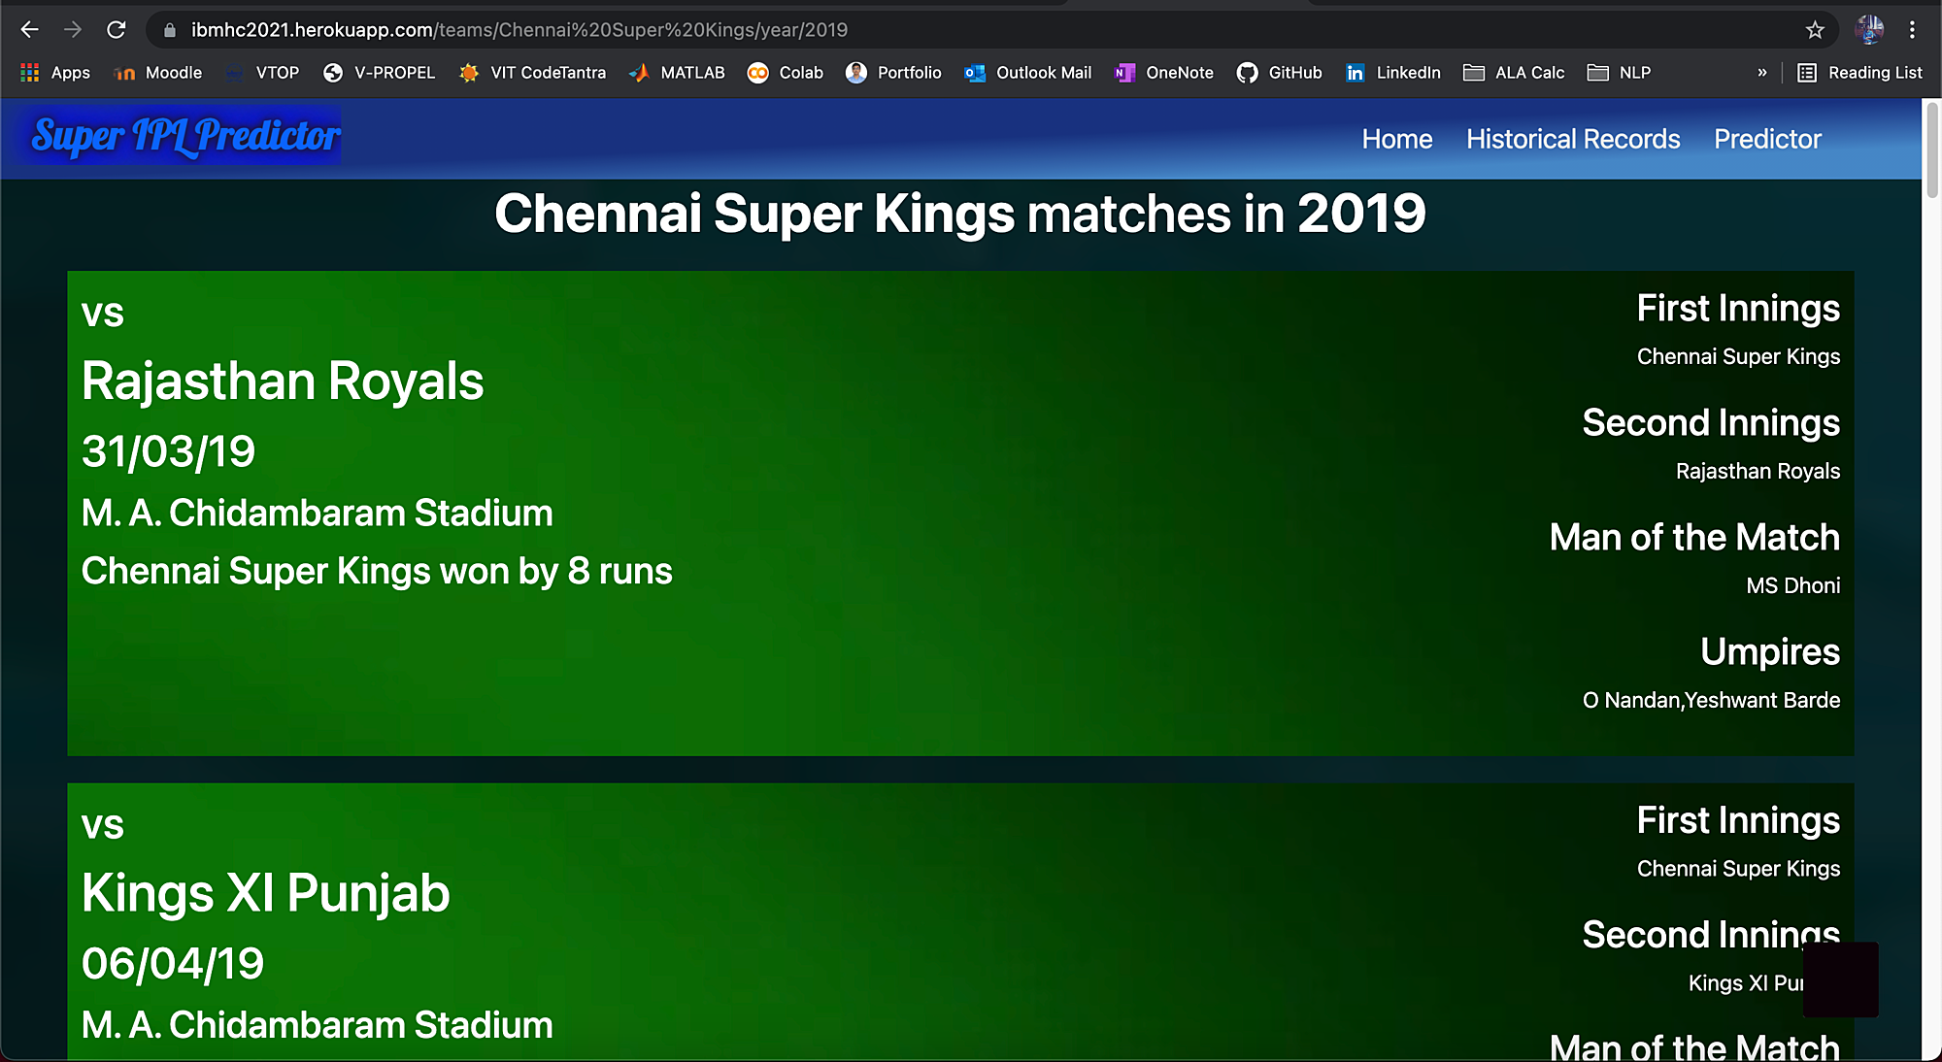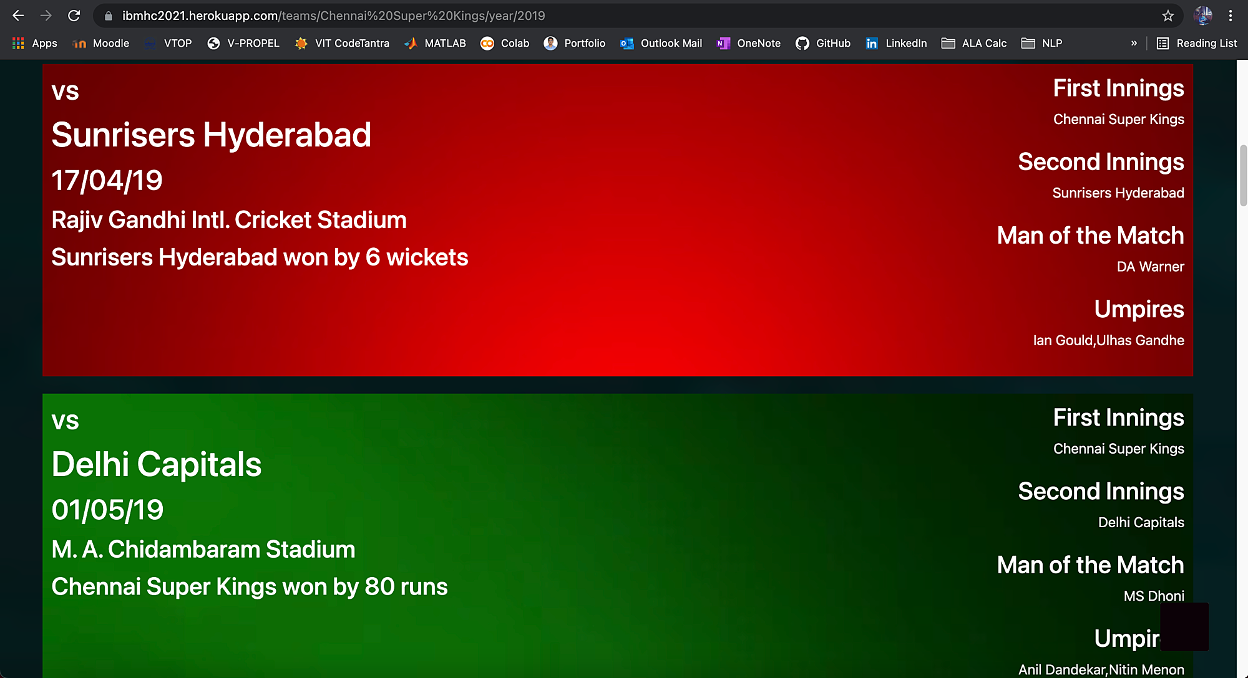

* To predict the first innings score given some parameters like the batting team, the bowling team, number of overs passed (>=5), number of runs scored so far, number of wickets taken so far, runs scored in previous 5 overs and wickets taken in previous 5 overs. Two models: Linear Regression and Random Forest Regressor were tested and Linear Regression (71.36%) was more accurate than Random Forest Regressor (63.84%). Hence, the backend used the Linear Regression model.

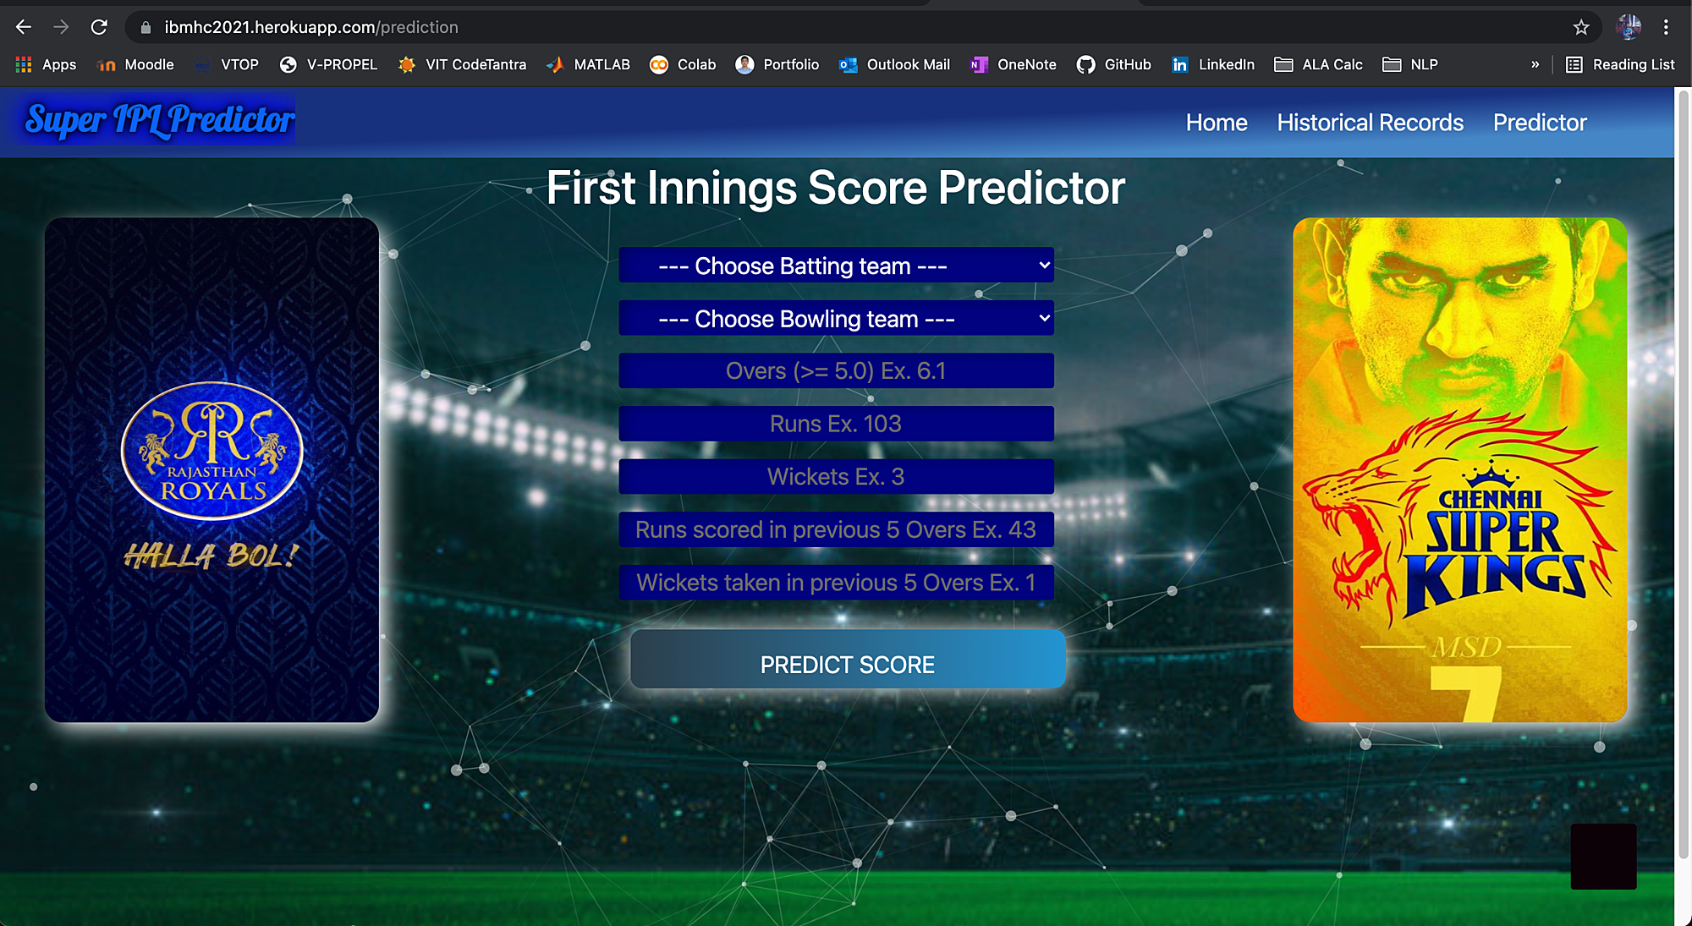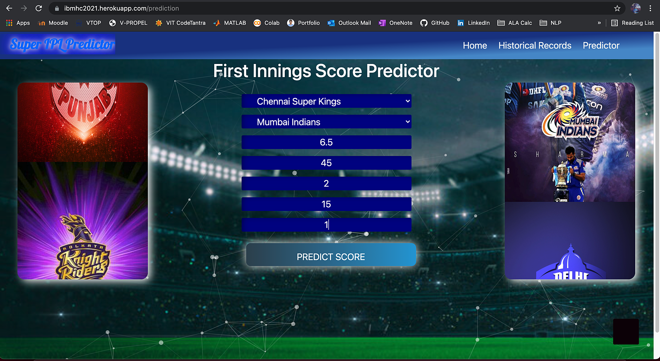

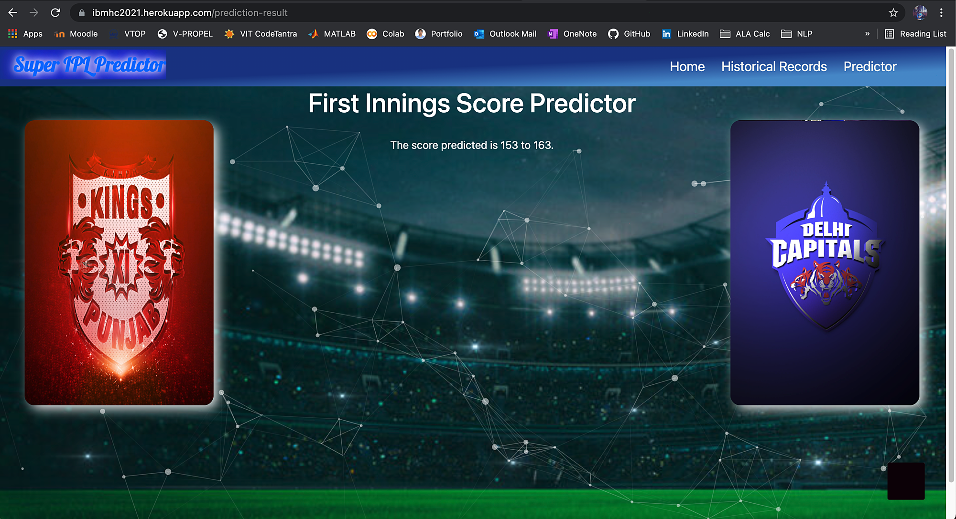

* To fecilitate the interaction of beginners with the UI, a chatbot (IPL Bot) was embedded which could answer basic questions related to the IPL.

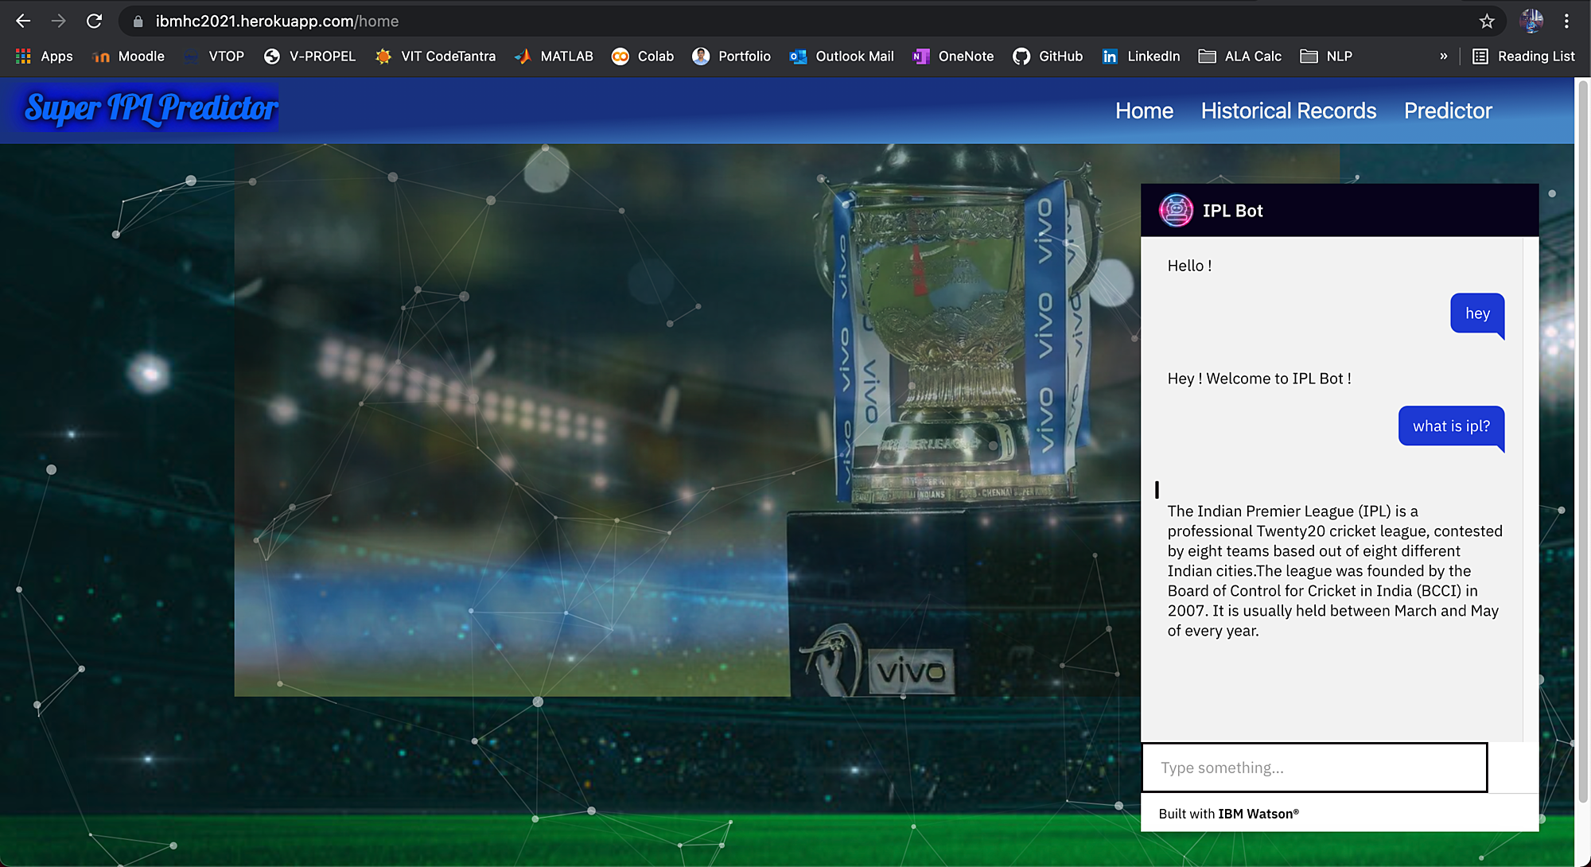

Apart from the UI, exploratory data analysis was performed on two different datasets related to IPL: match-oriented and ball-by-ball. Different perspectives focused in the analysis included:

* Overall statistics (based on match-oriented dataset)
* Powerplay, Middle Overs and Death Overs statistics (based on ball-by-ball dataset)
* Highest Run Scorers and Wicket Takers (based on ball-by-ball dataset)

The above outcomes/perspectives were further visualised in Cognos Dashboard.

***Overall Statistics***

* Team that secured the most number of wins are Mumbai Indians. Similarly, the team secured the least number of wins are Kochi Tuskers Kerala. Furtherly, there are 52% chances of victory of winning the match if the team wins the toss. This analytics can be split furtherly into: winning toss, batting first and winning the match- where there are 82.3% chances of facing a defeat; winning toss, fielding first and winning the match- where ther are 65.7% chances of facing a defeat.

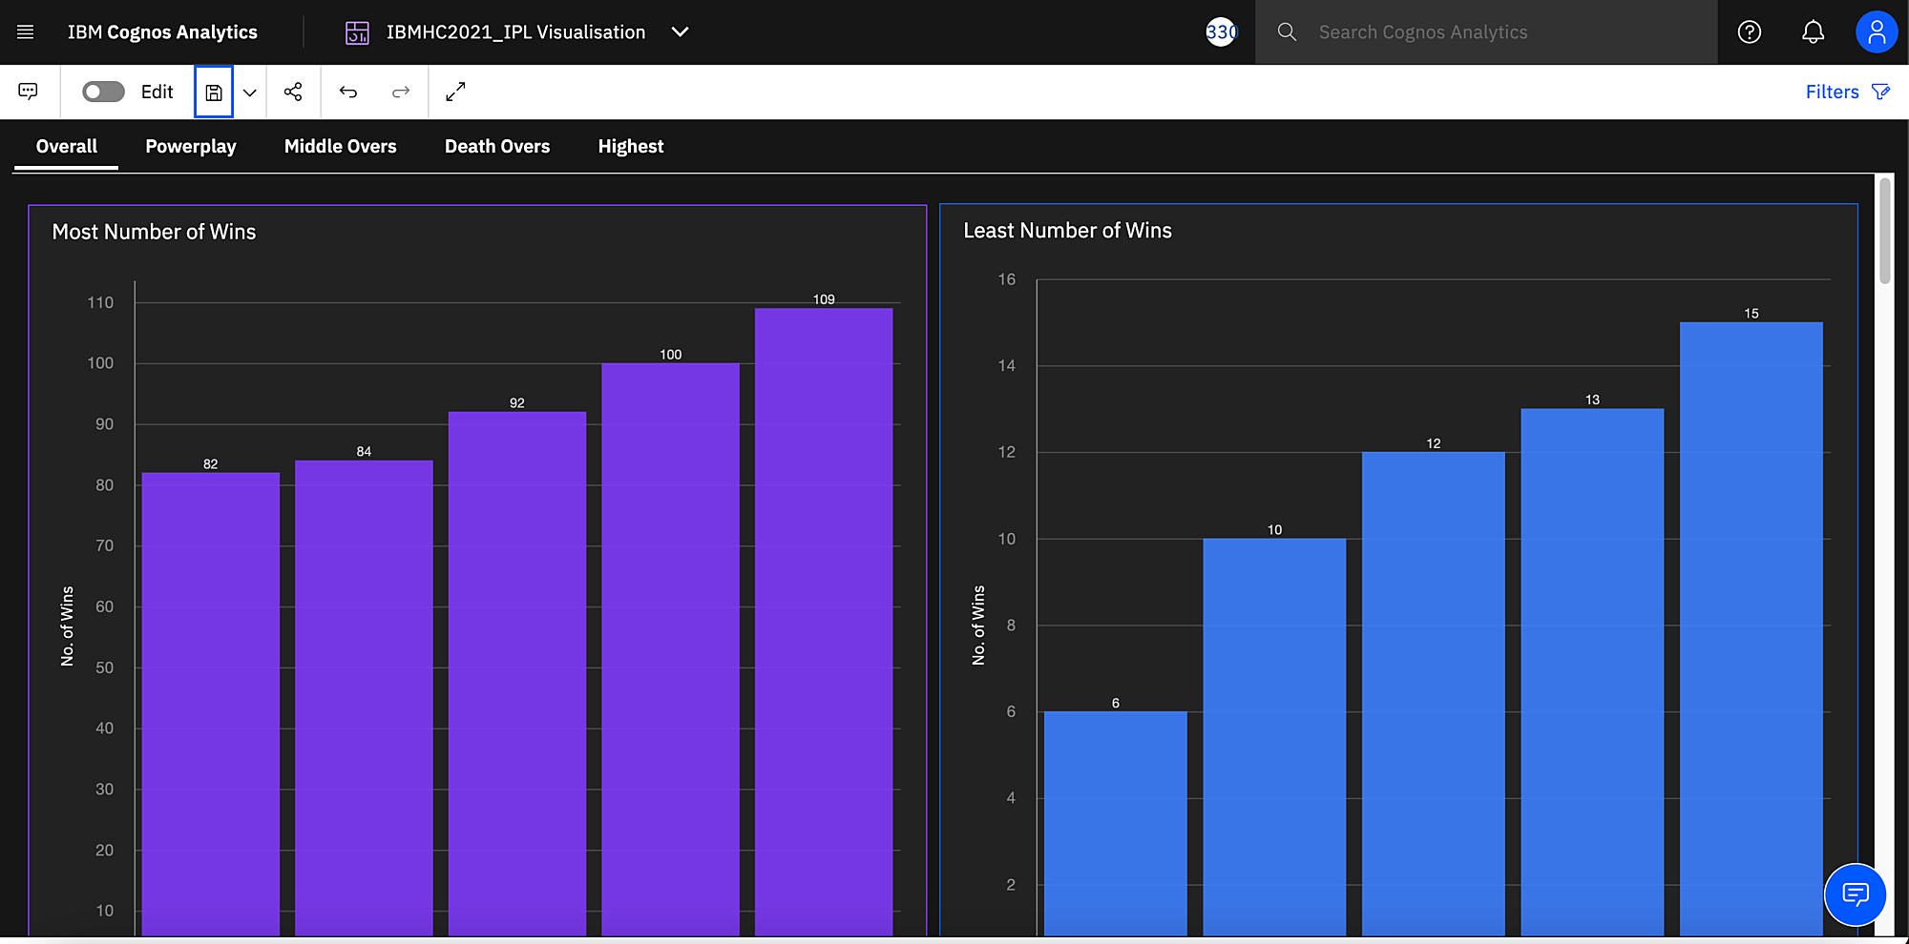

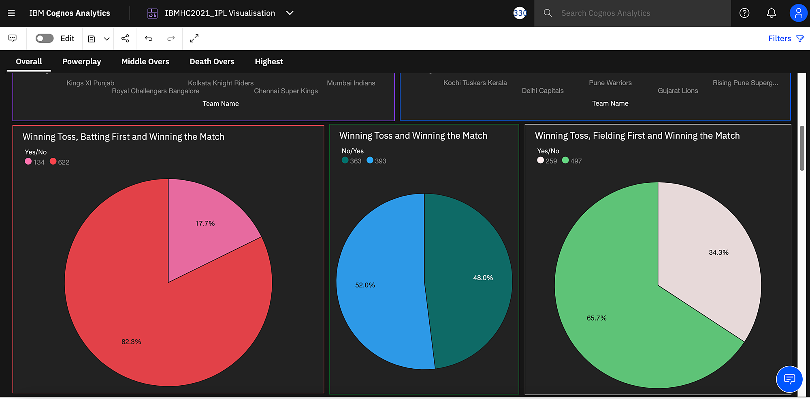

* Year in which each team secured maximum number of wins:

1. CSK-2013
2. DC (Deccan Chargers)-2009
3. DC (Delhi Capitals)-2019
4. GL-2016
5. KXIP-2014
6. KTK-2011
7. KKR-2014
8. MI-2013
9. PWI-2011,2012,2013
10. RR-2018

* Considering all the seasons, the stadium that hosted most number of matches are Eden Gardens.
* Maximum number of MoM was won by CH Gayle.
* The largest margin of victory while defending a total was 146 runs, where MI won against DD in the year 2017.

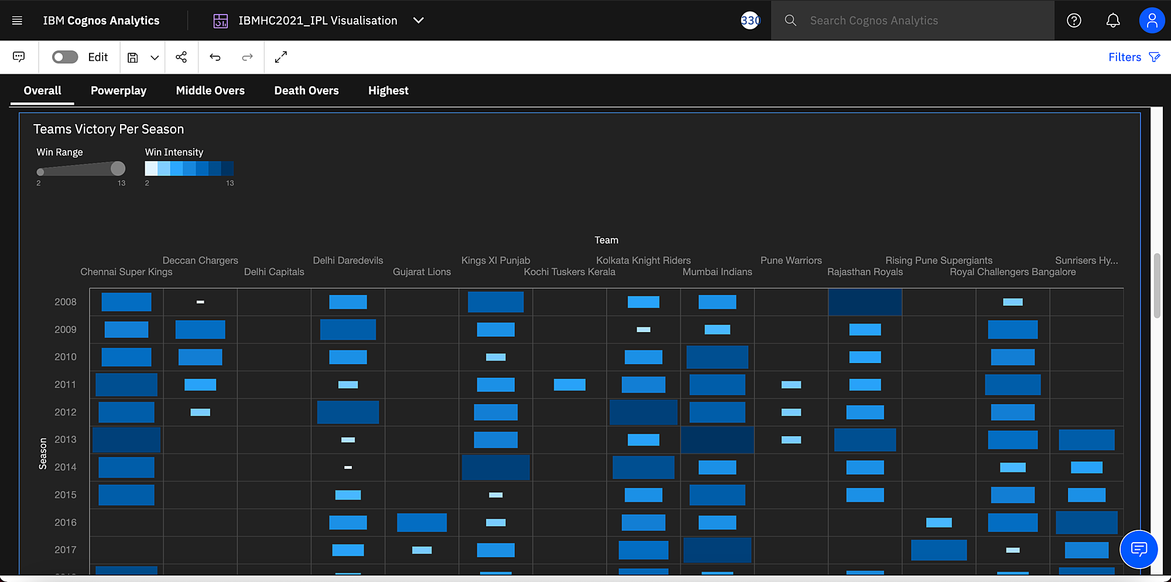

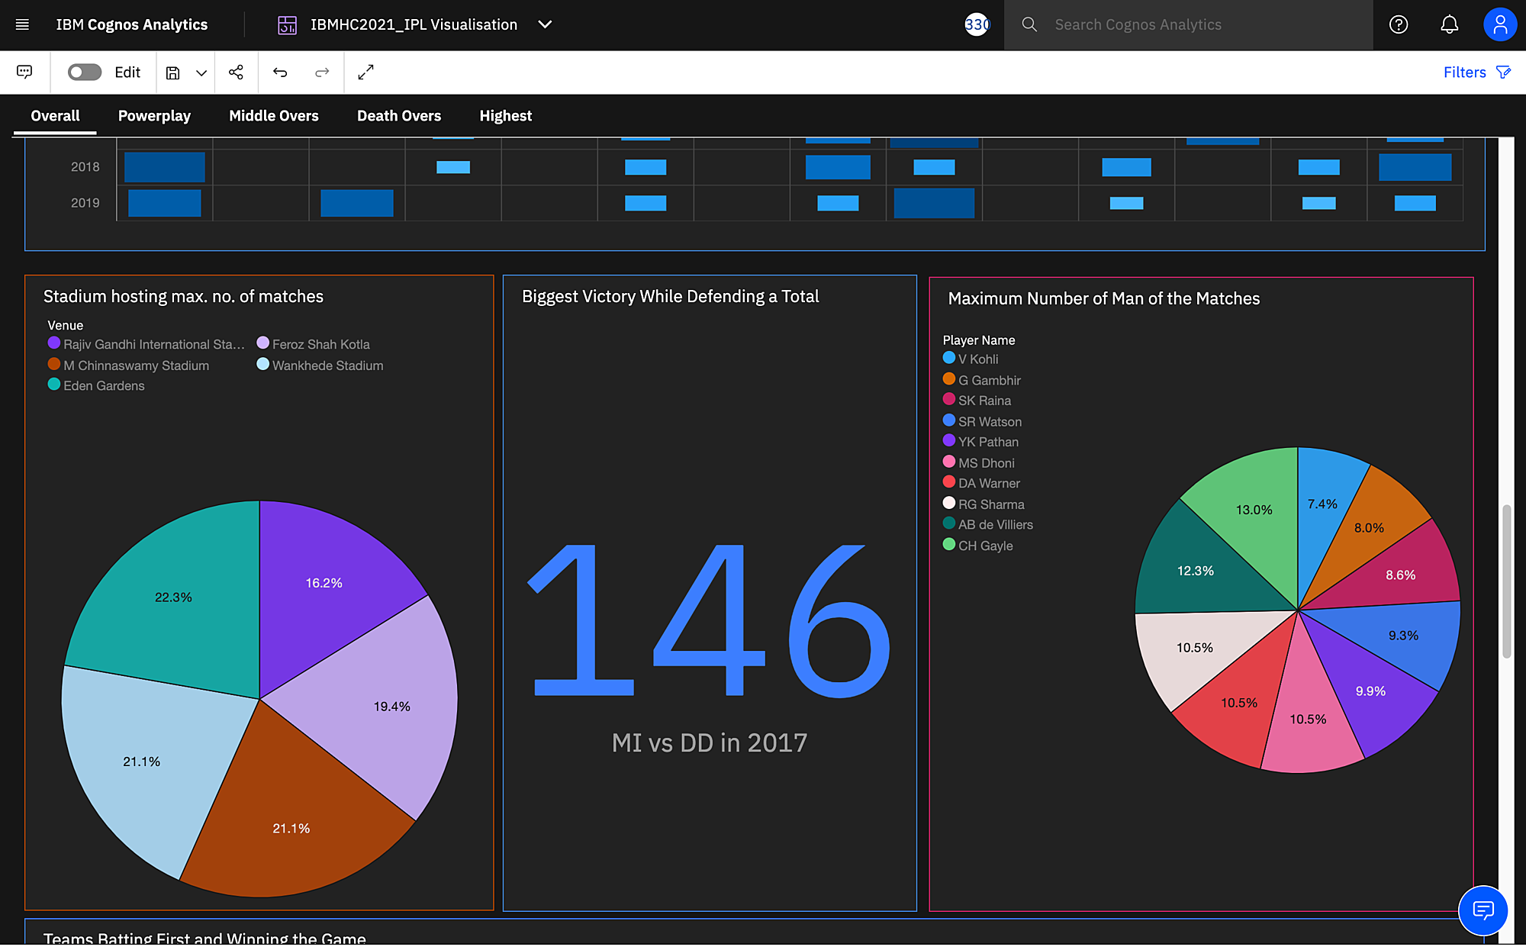

* Team that won most number of matches batting first are Mumbai Indians. Again, team that won most number of matches fielding first are Mumbai Indians.

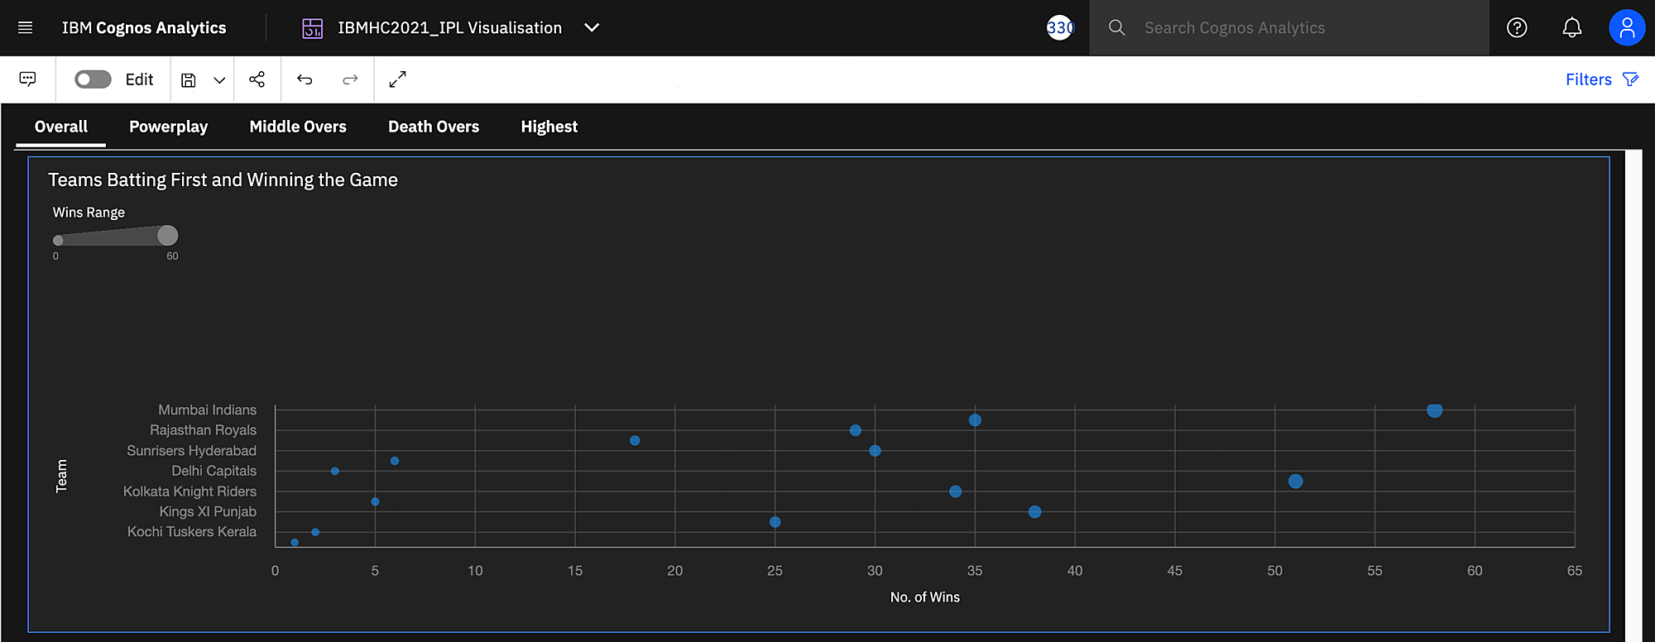

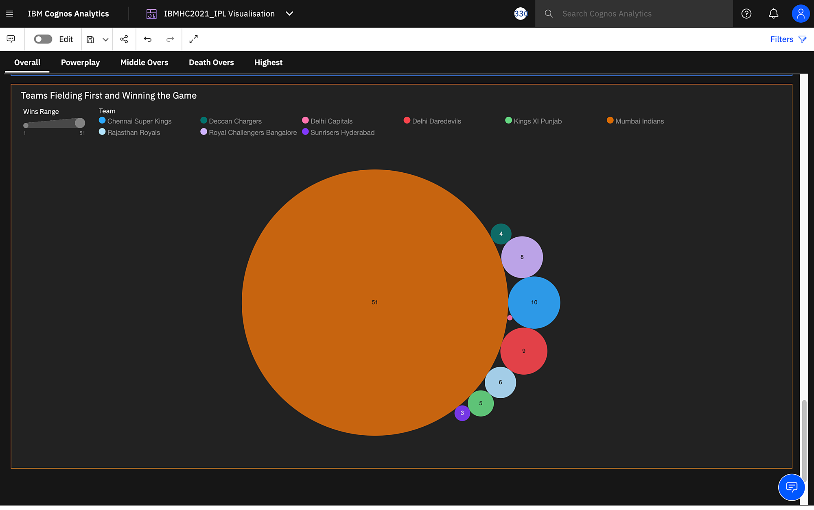

***Powerplay Statistics***

* CSK had the highest average powerplay score of 50.24 while SRH had the highest run rate in powerplay of 9.01.

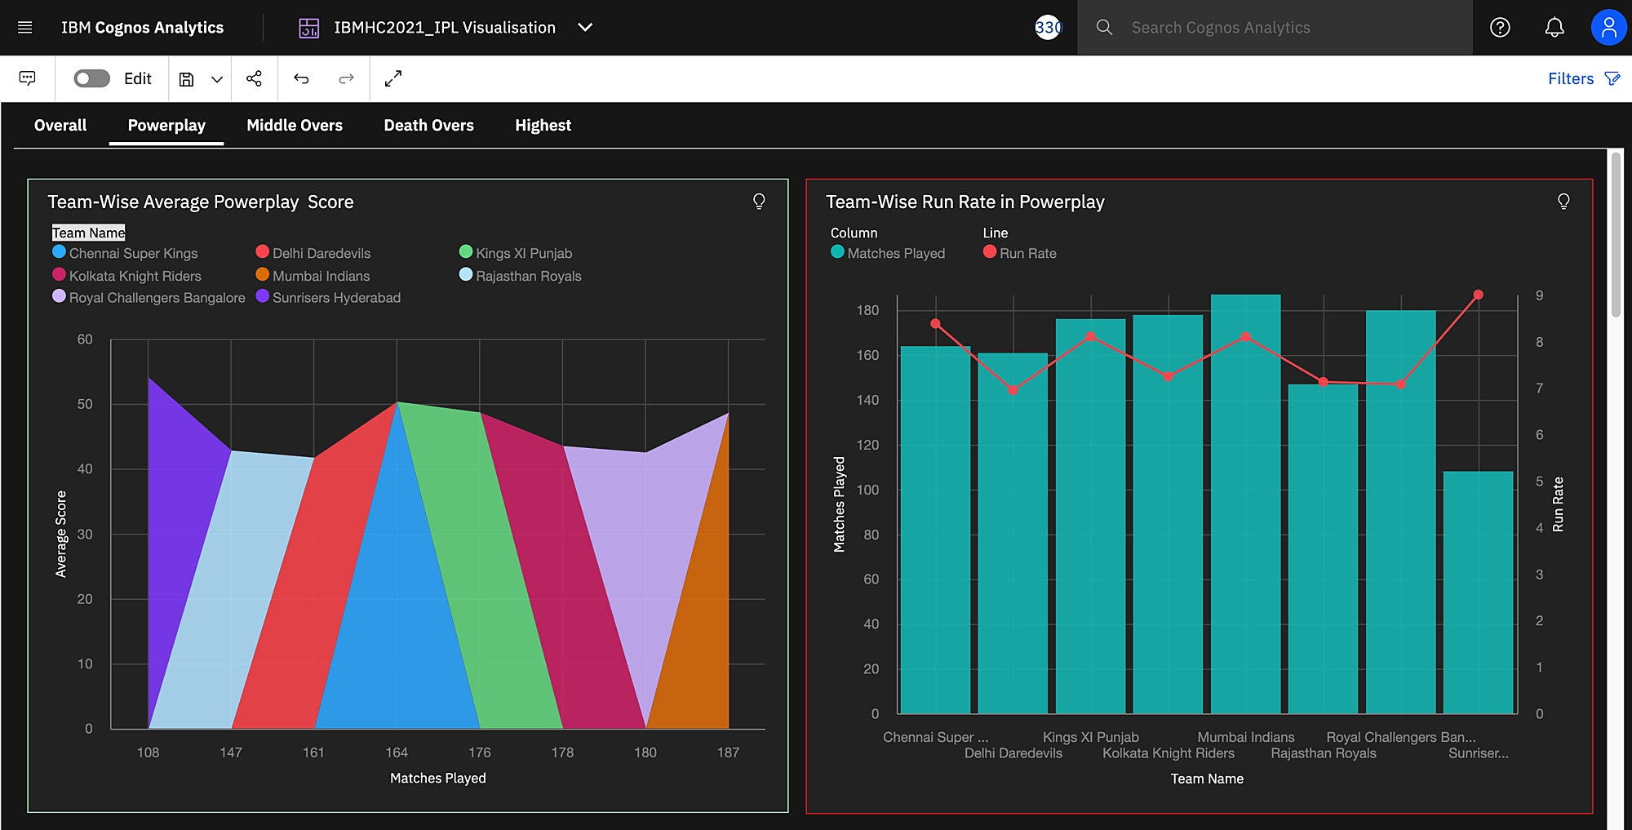

* KKR, DD and KXIP had the highest average number of dismissals in powerplay, with KKR having the highest number of dismissals.

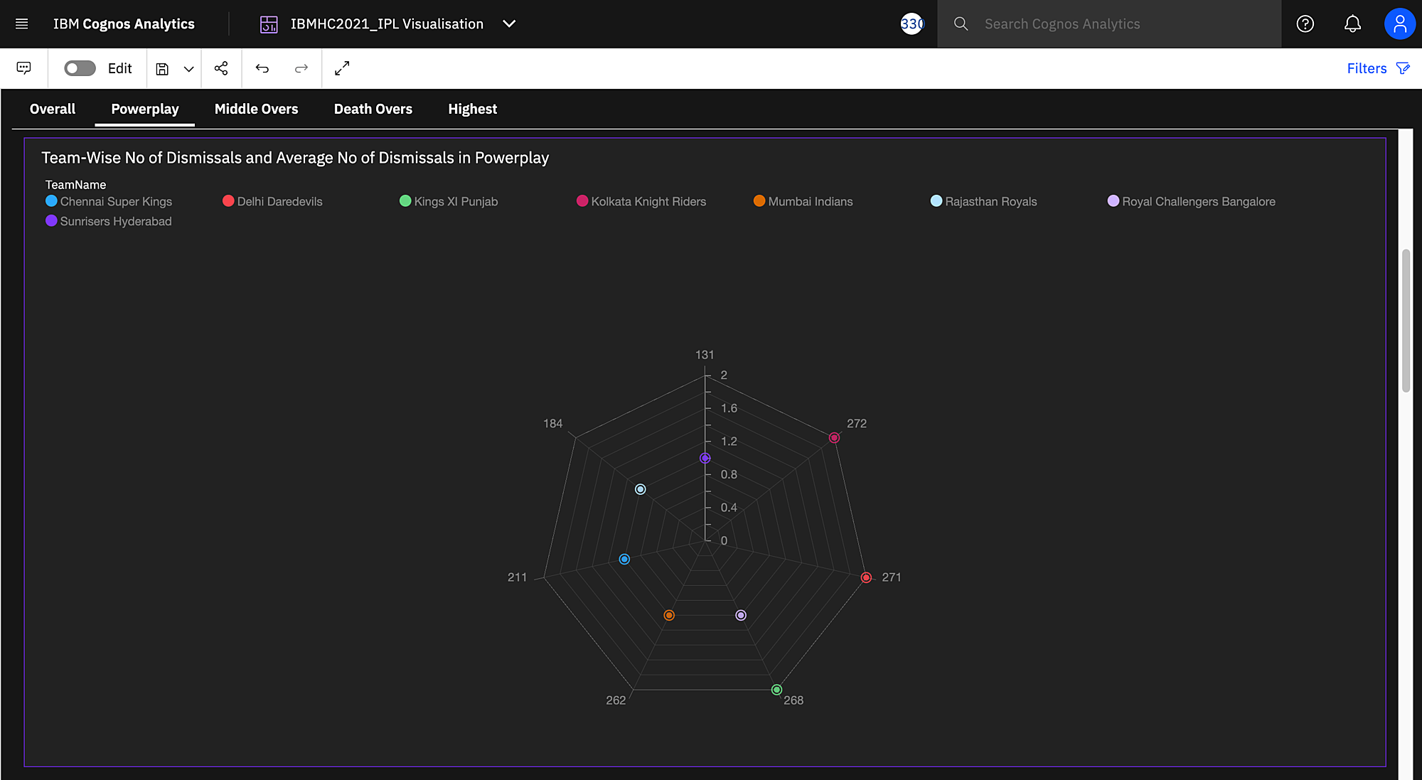

* CSK and RR had the highest average number of wickets taken in powerplay and the highest number of wickets taken.

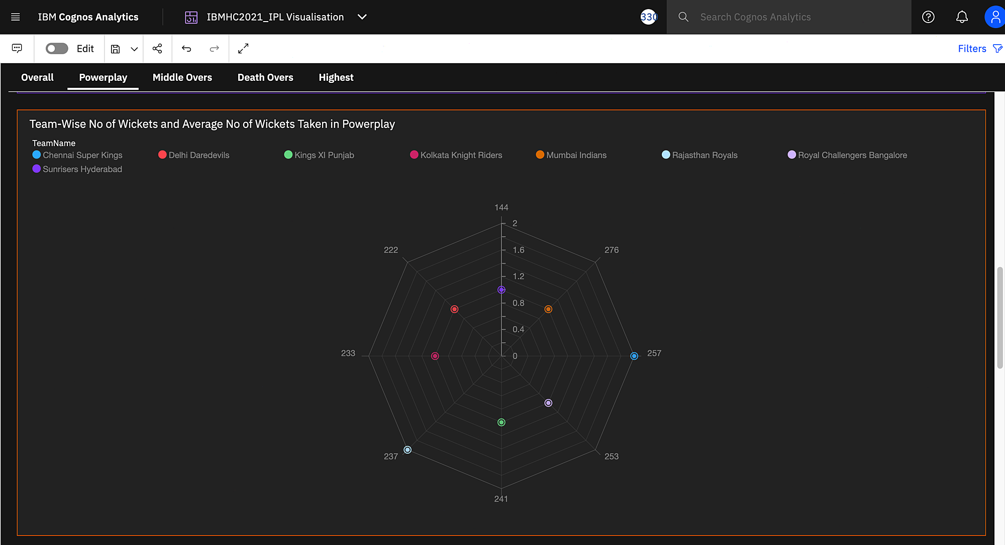

* Furtherly, two graphs with the ability to fitler team-wise, showed the number of times a player was dimissed and number of wickets taken by a player in powerplay.

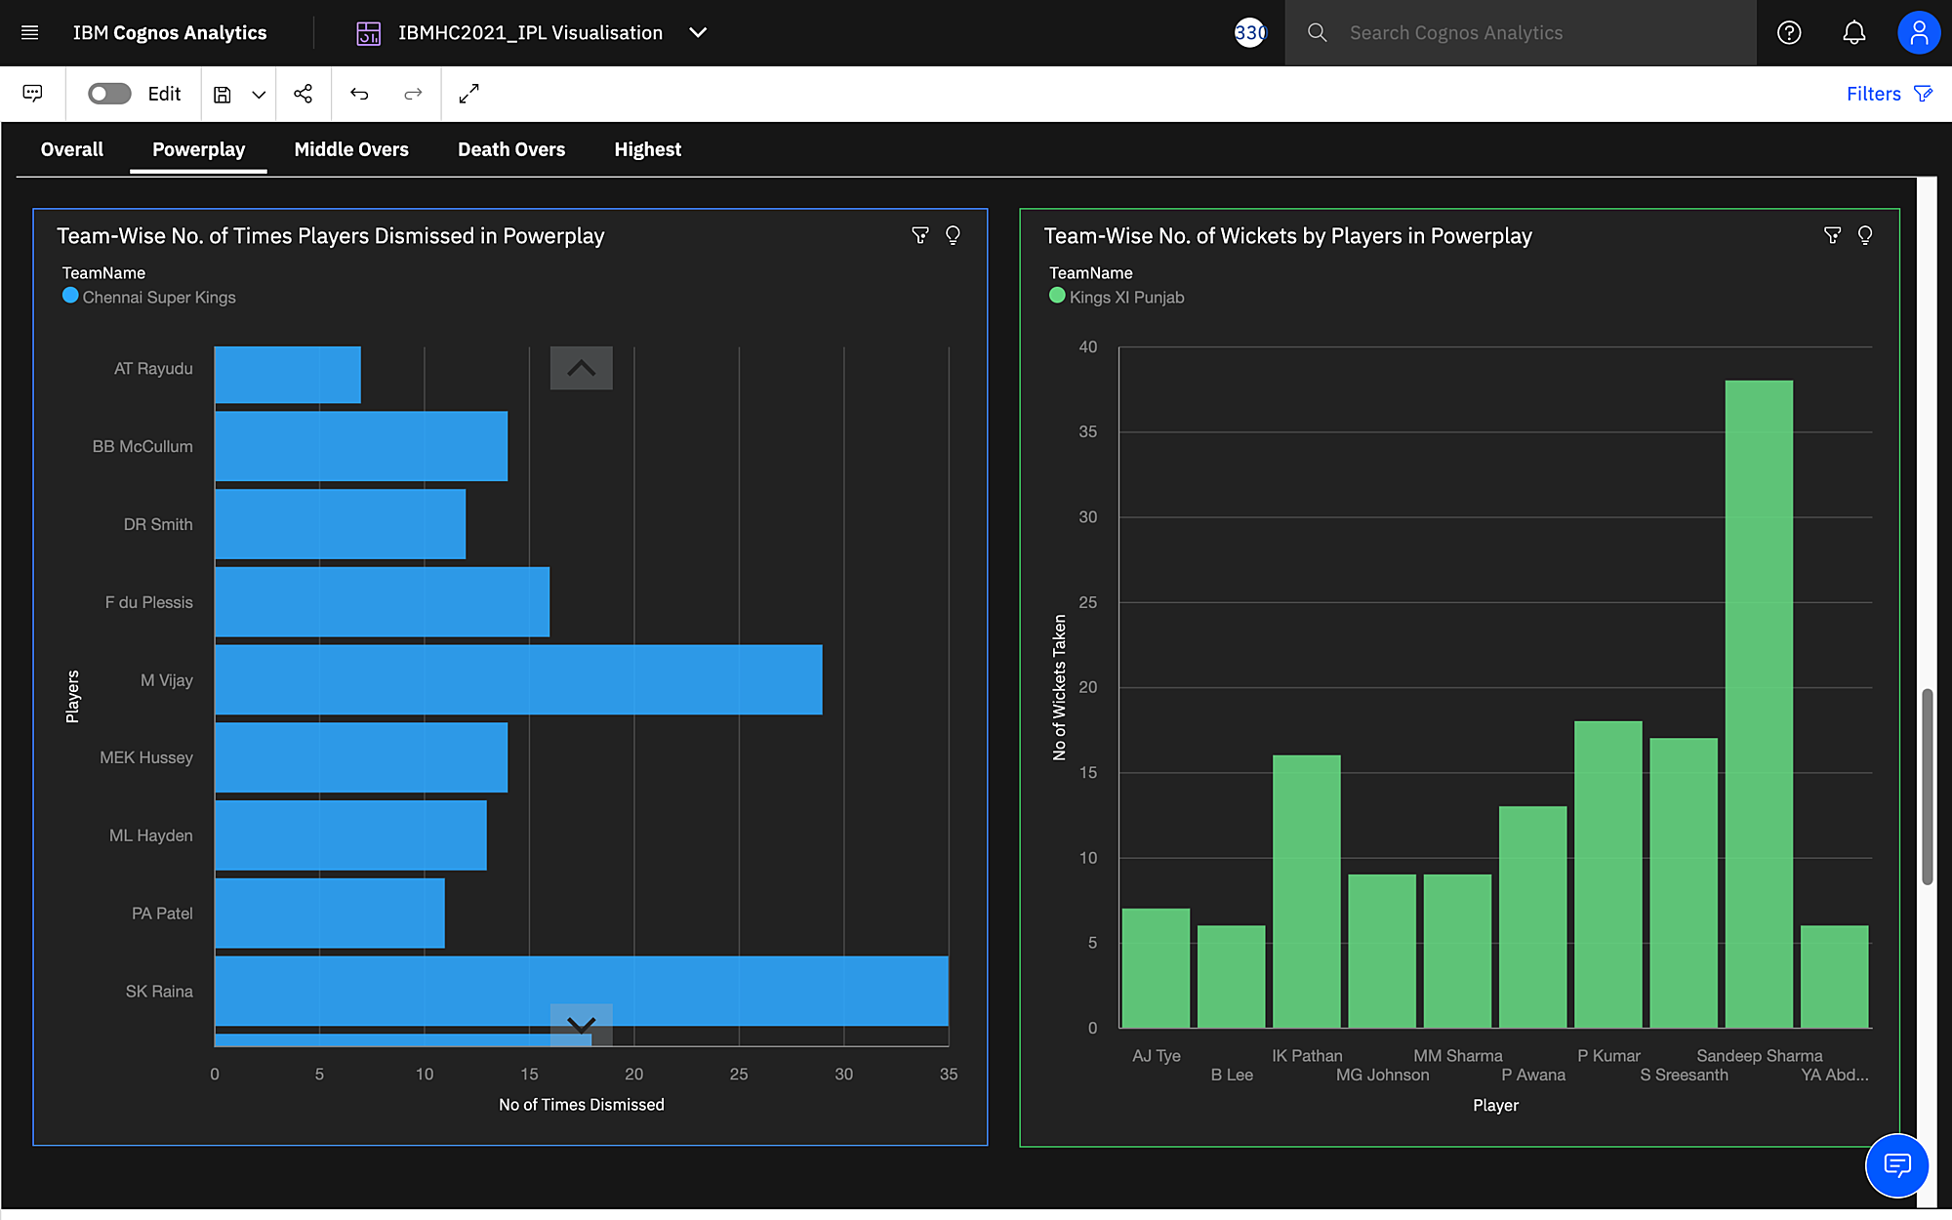

***Middle Overs Statistics***

* CSK had the highest average middle over score of 64.74 while SRH had the highest run rate in middle overs of 68.56.

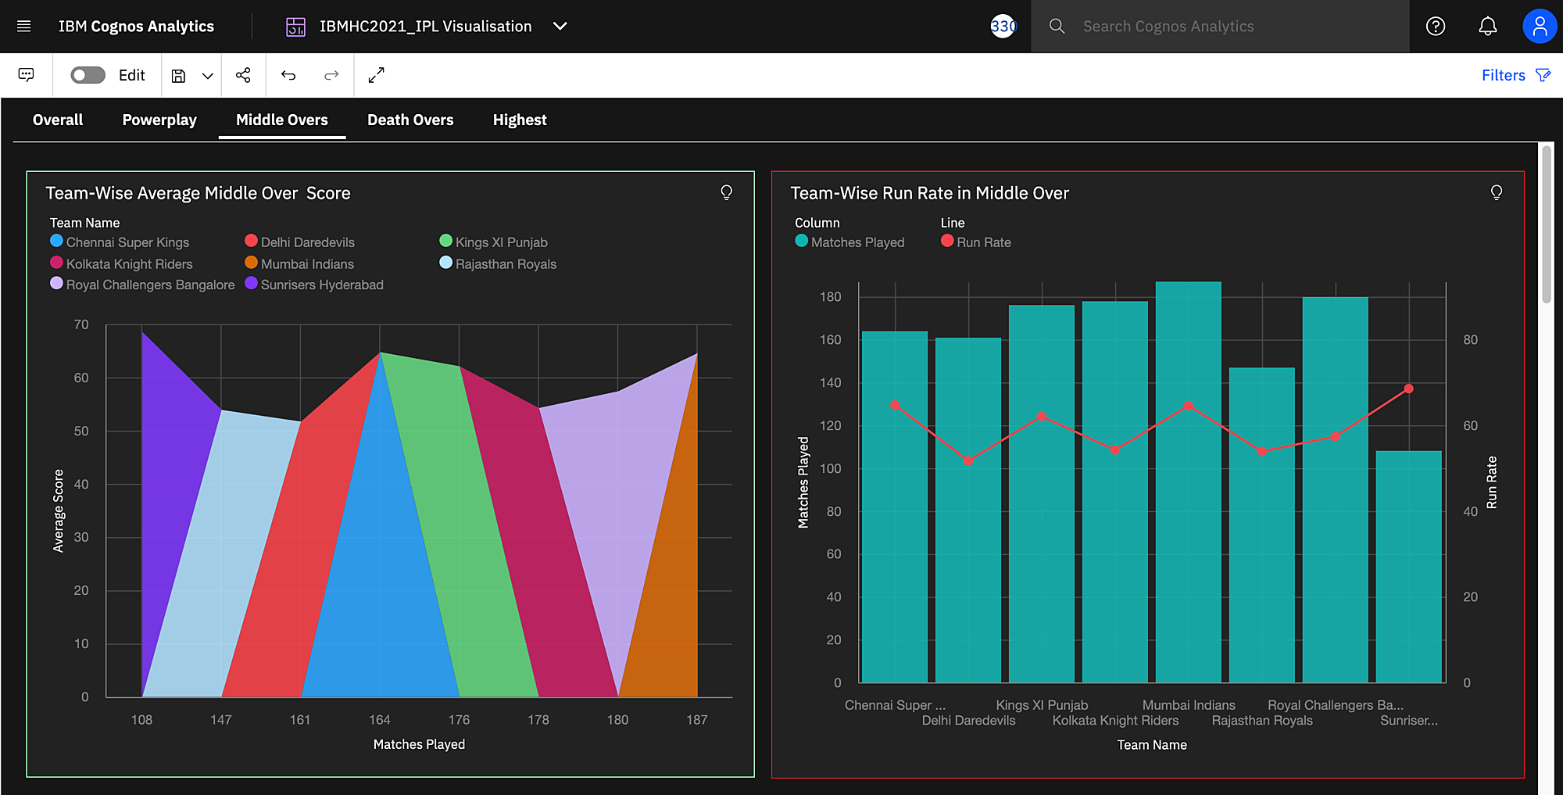

* All teams had the same average number of dismissals in middle overs while Mumbai Indian had the most number of dismissals.

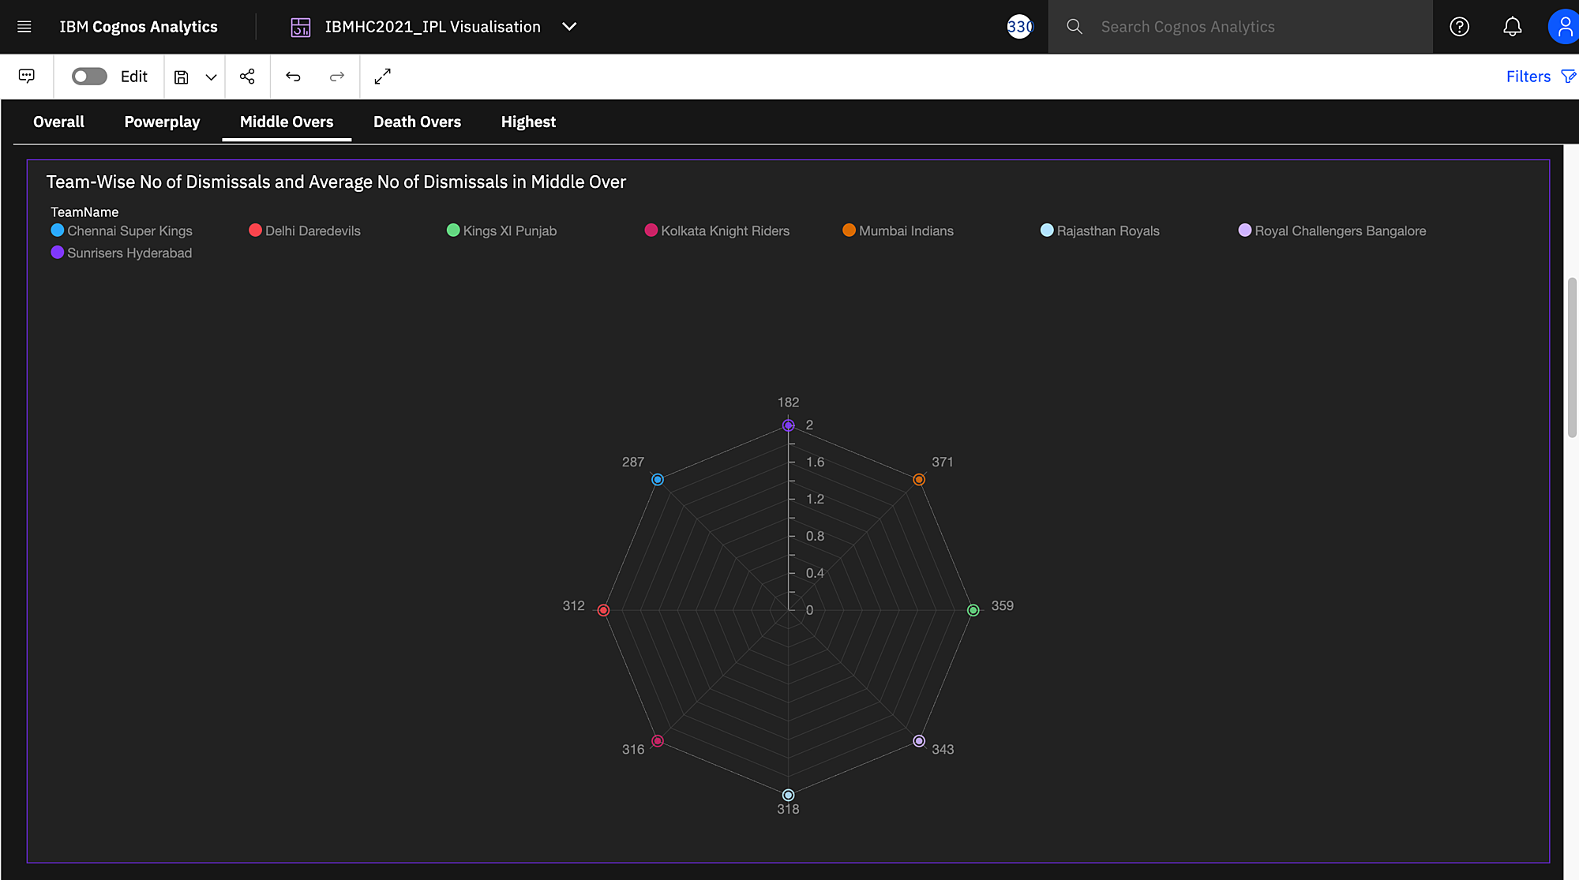

* All teams had the same average number of wickets taken in middle overs while Mumbai Indian had the most number of wicketst taken.

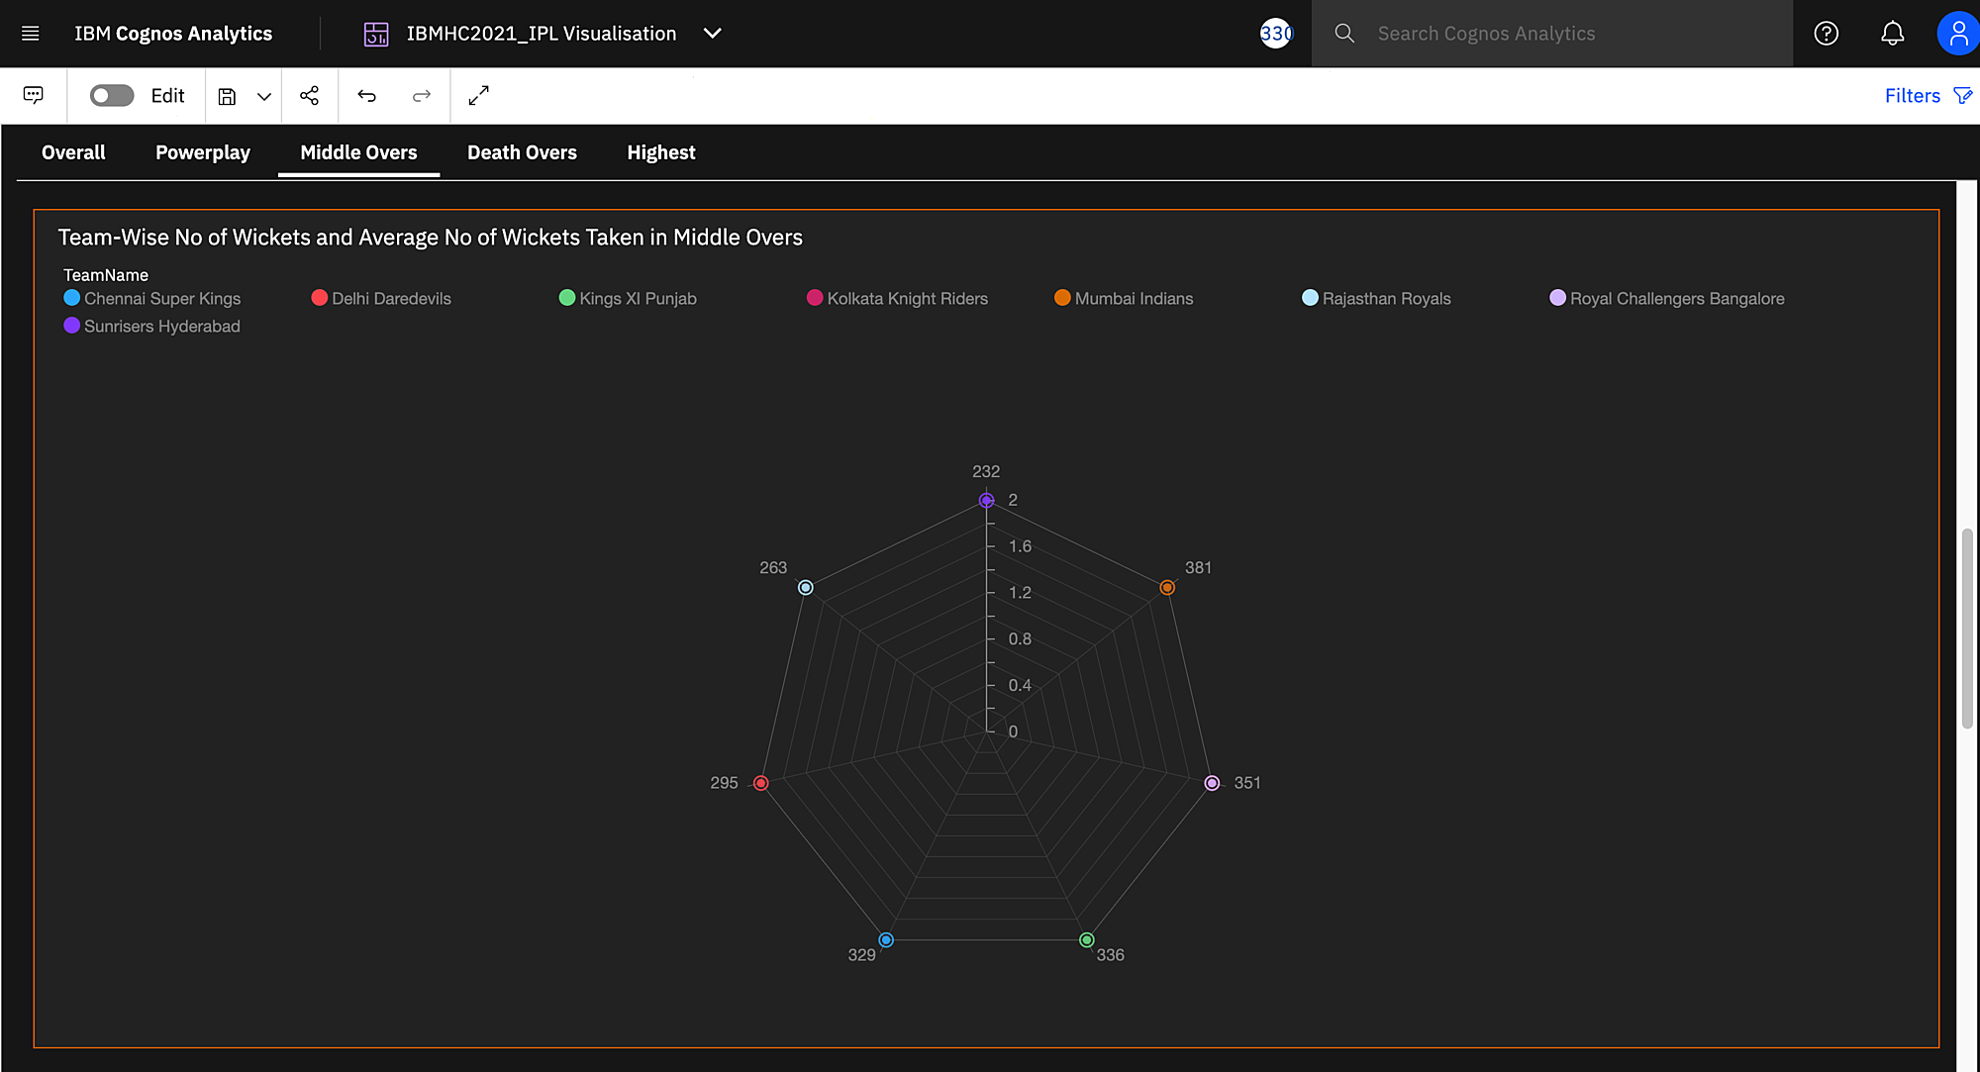

* Furtherly, two graphs with the ability to fitler team-wise, showed the number of times a player was dimissed and number of wickets taken by a player in middle overs.

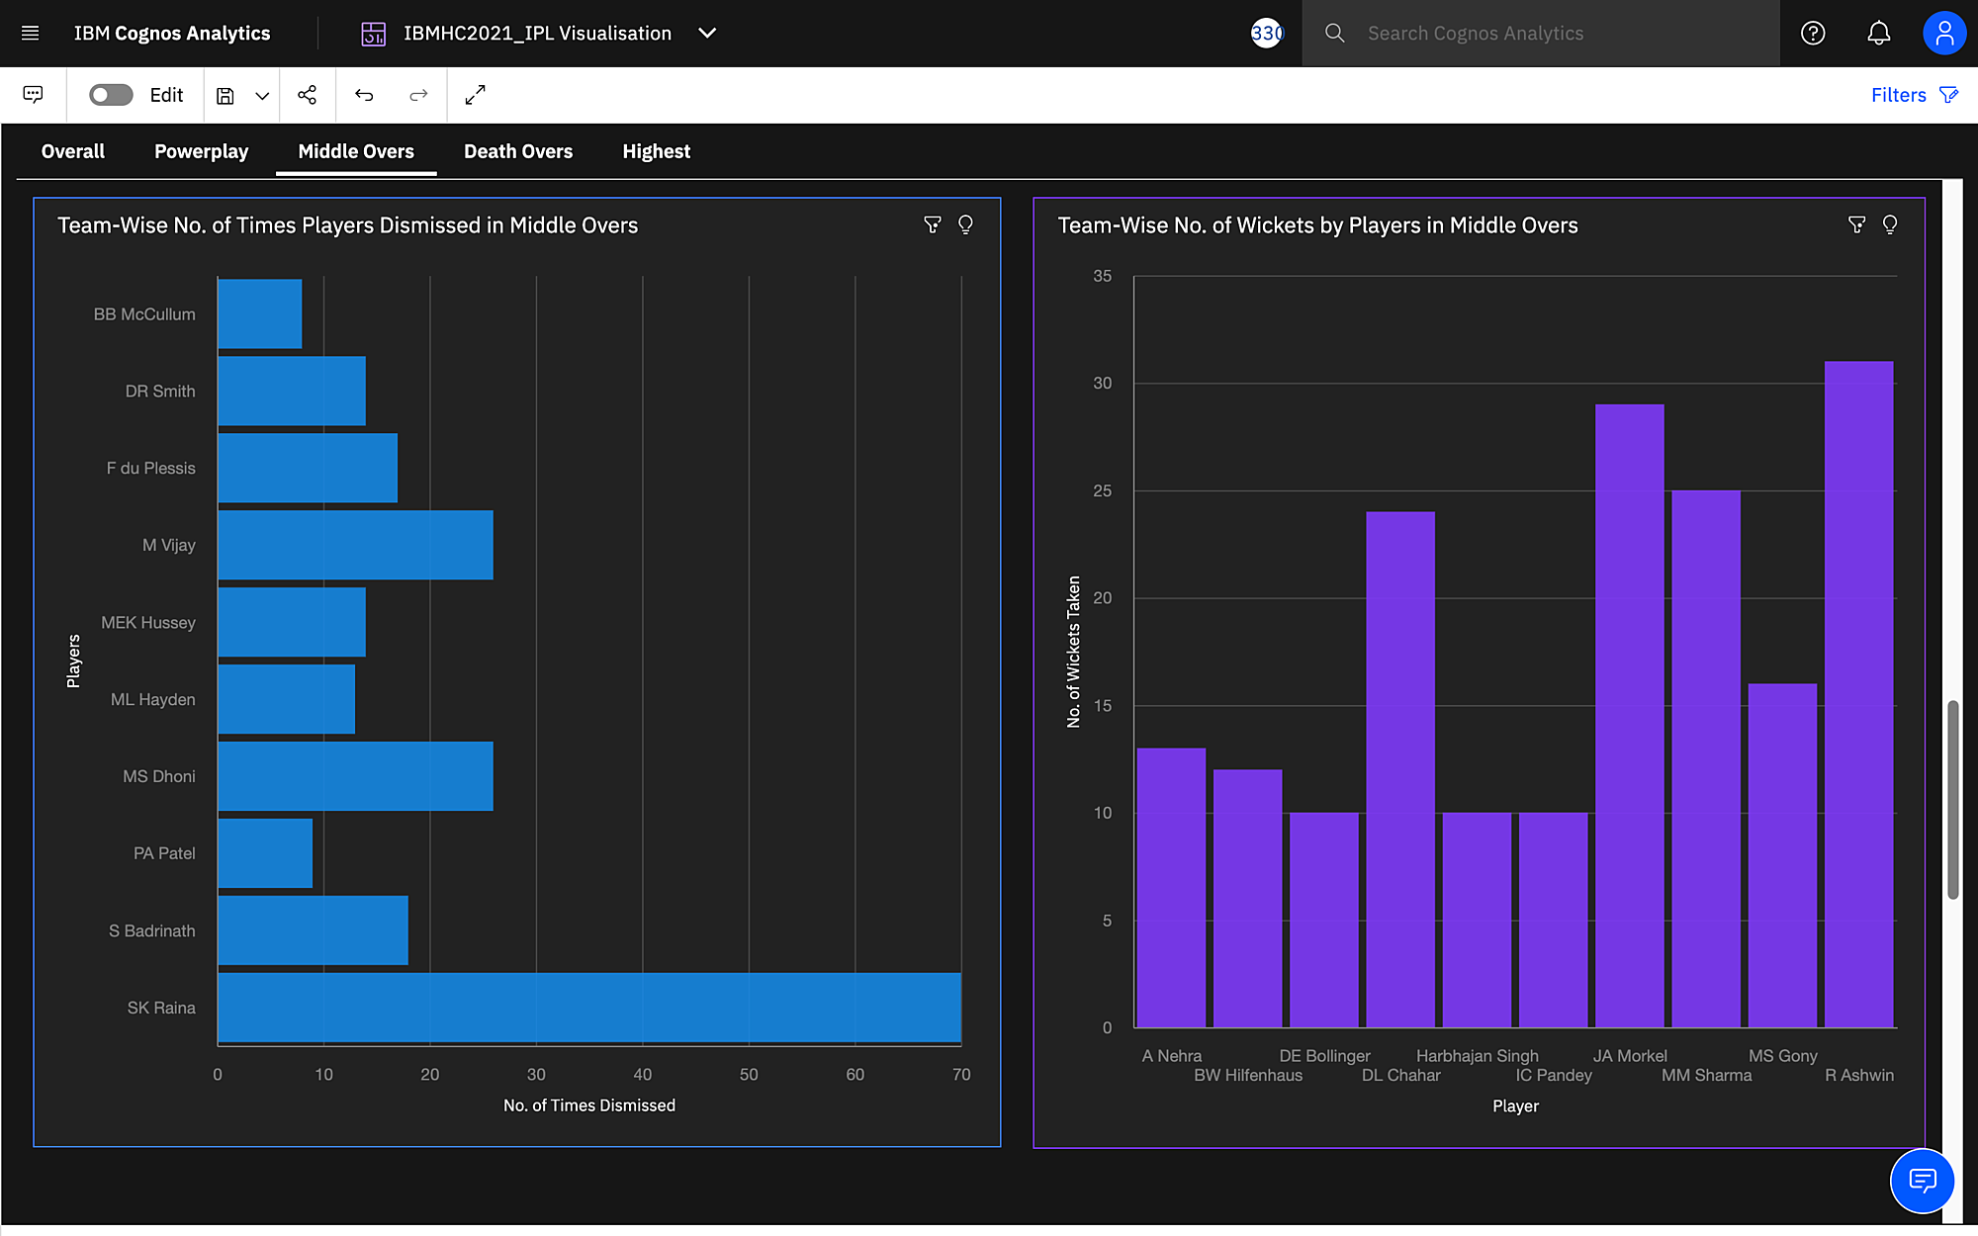

***Death Overs Statistics***

* CSK had the highest average death over score of 25.03 while SRH had the highest run rate in death overs of 9.79.

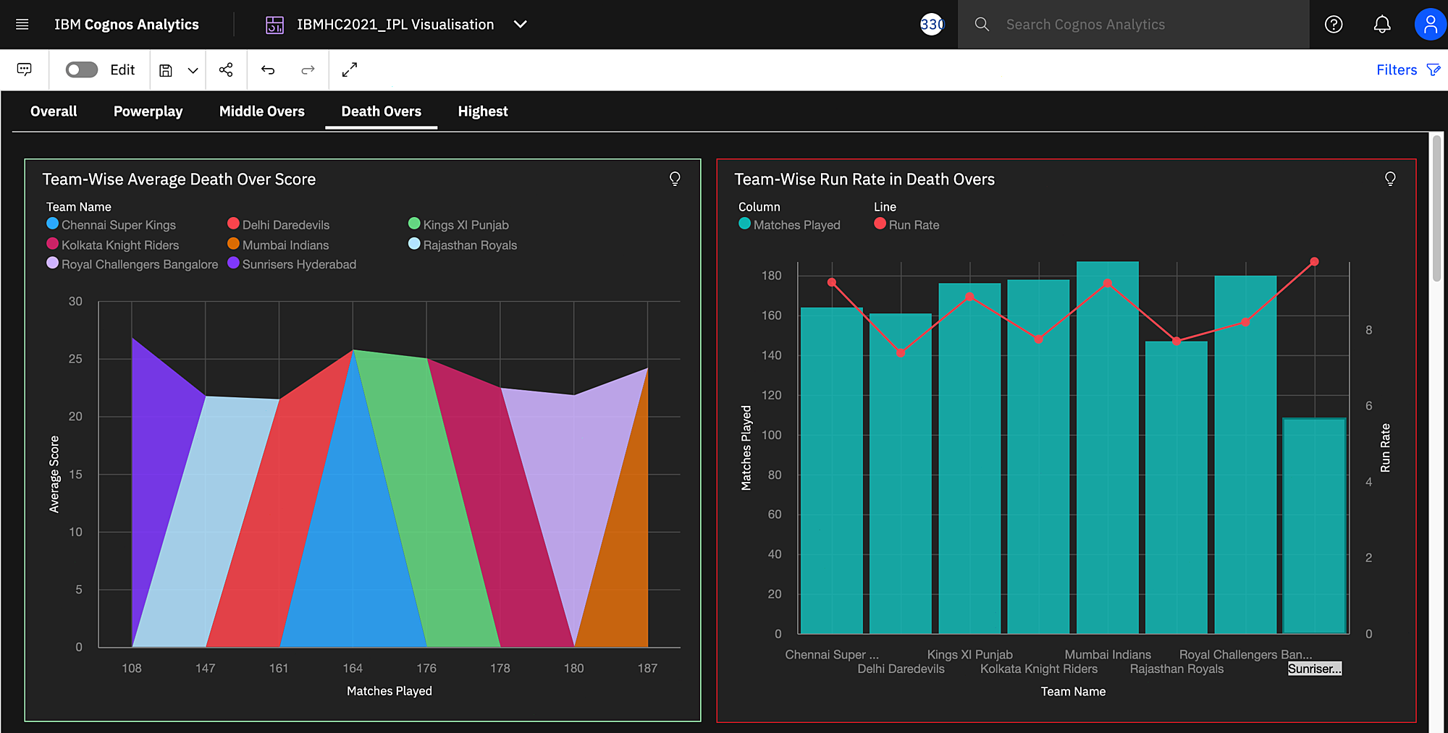

* SRH and KXIP had the highest average number of dismissals in death overs, while KXIP had the highest number of dismissals.

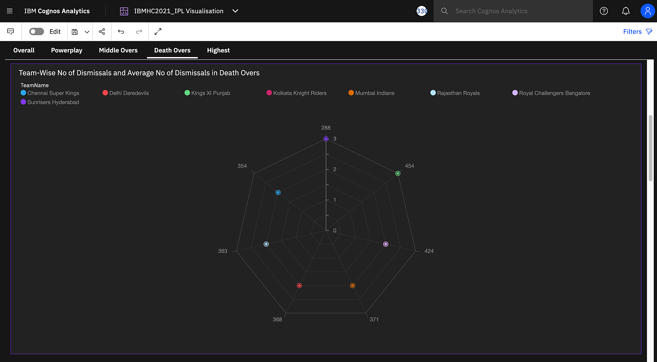

* MI and CSK had highest average number of wickets taken in death overs, while MI had the highest number of wickets taken.

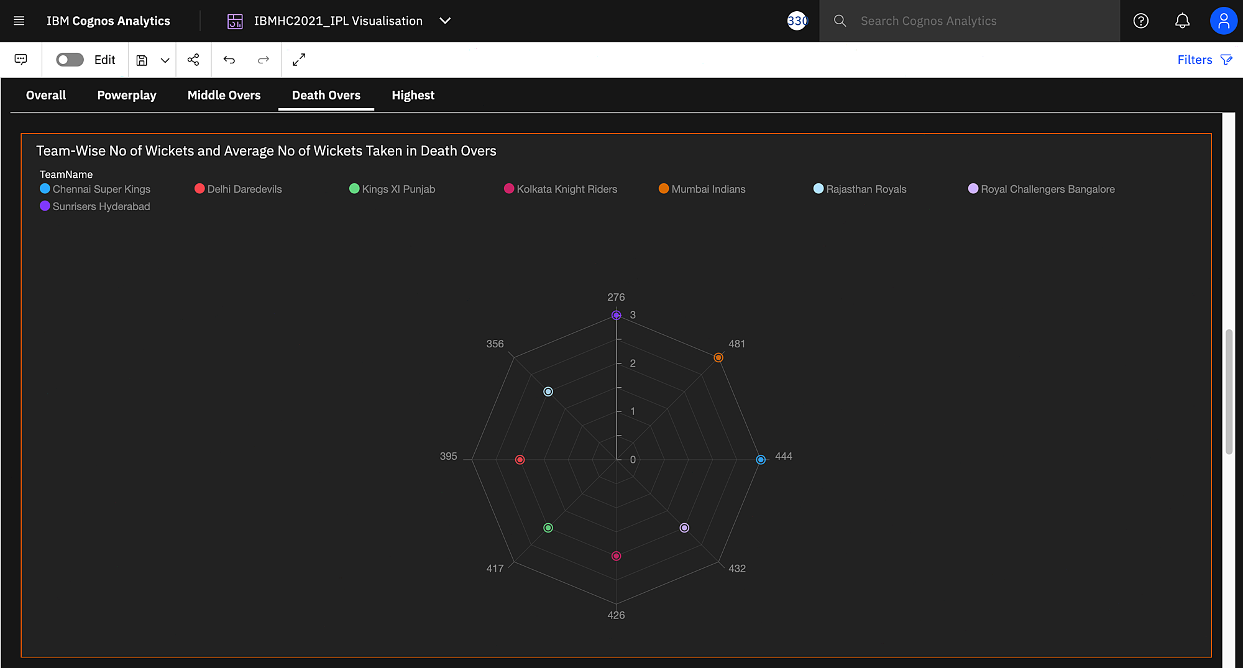

* Furtherly, two graphs with the ability to fitler team-wise, showed the number of times a player was dimissed and number of wickets taken by a player in death overs.

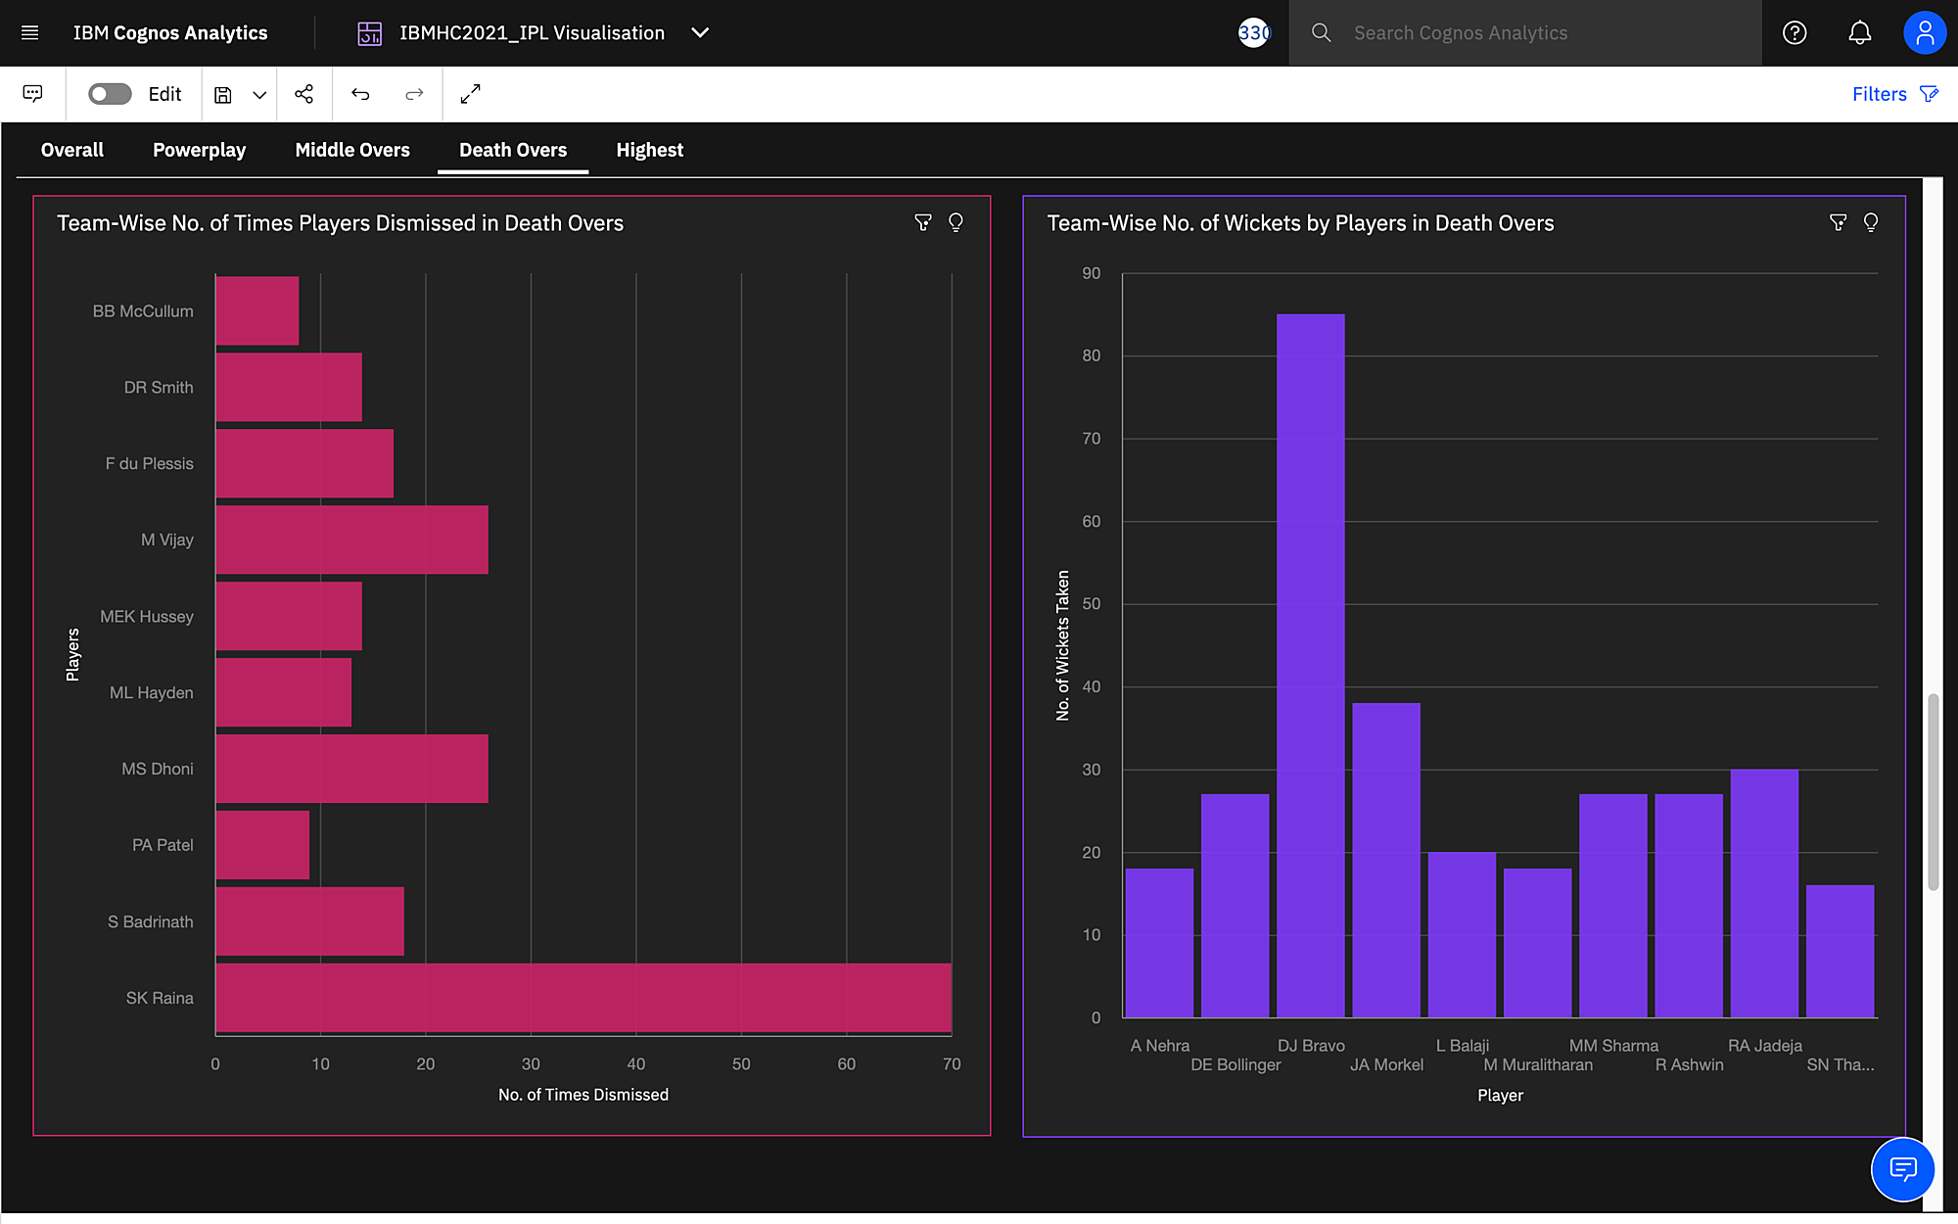

***Highest Run Scorers and Wicket Takers***

* V Kohli had scored the most number of runs (5434) in the history of IPL.

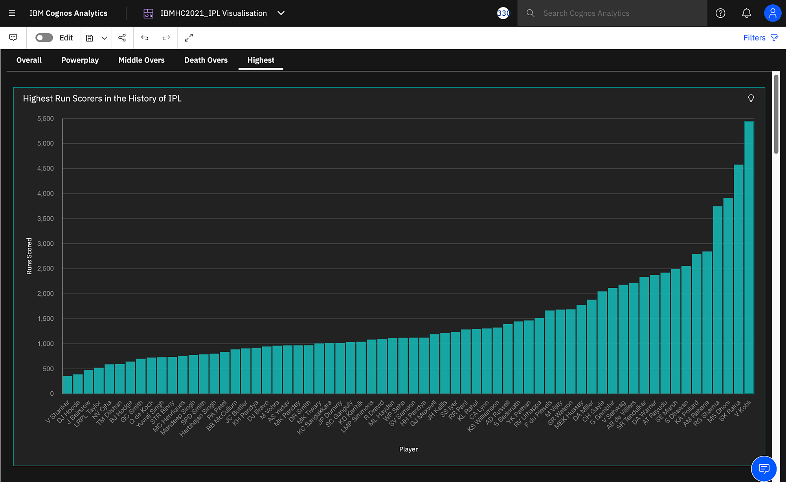

* SL Malinga had taken the most number of wickets (187) in the history of IPL.

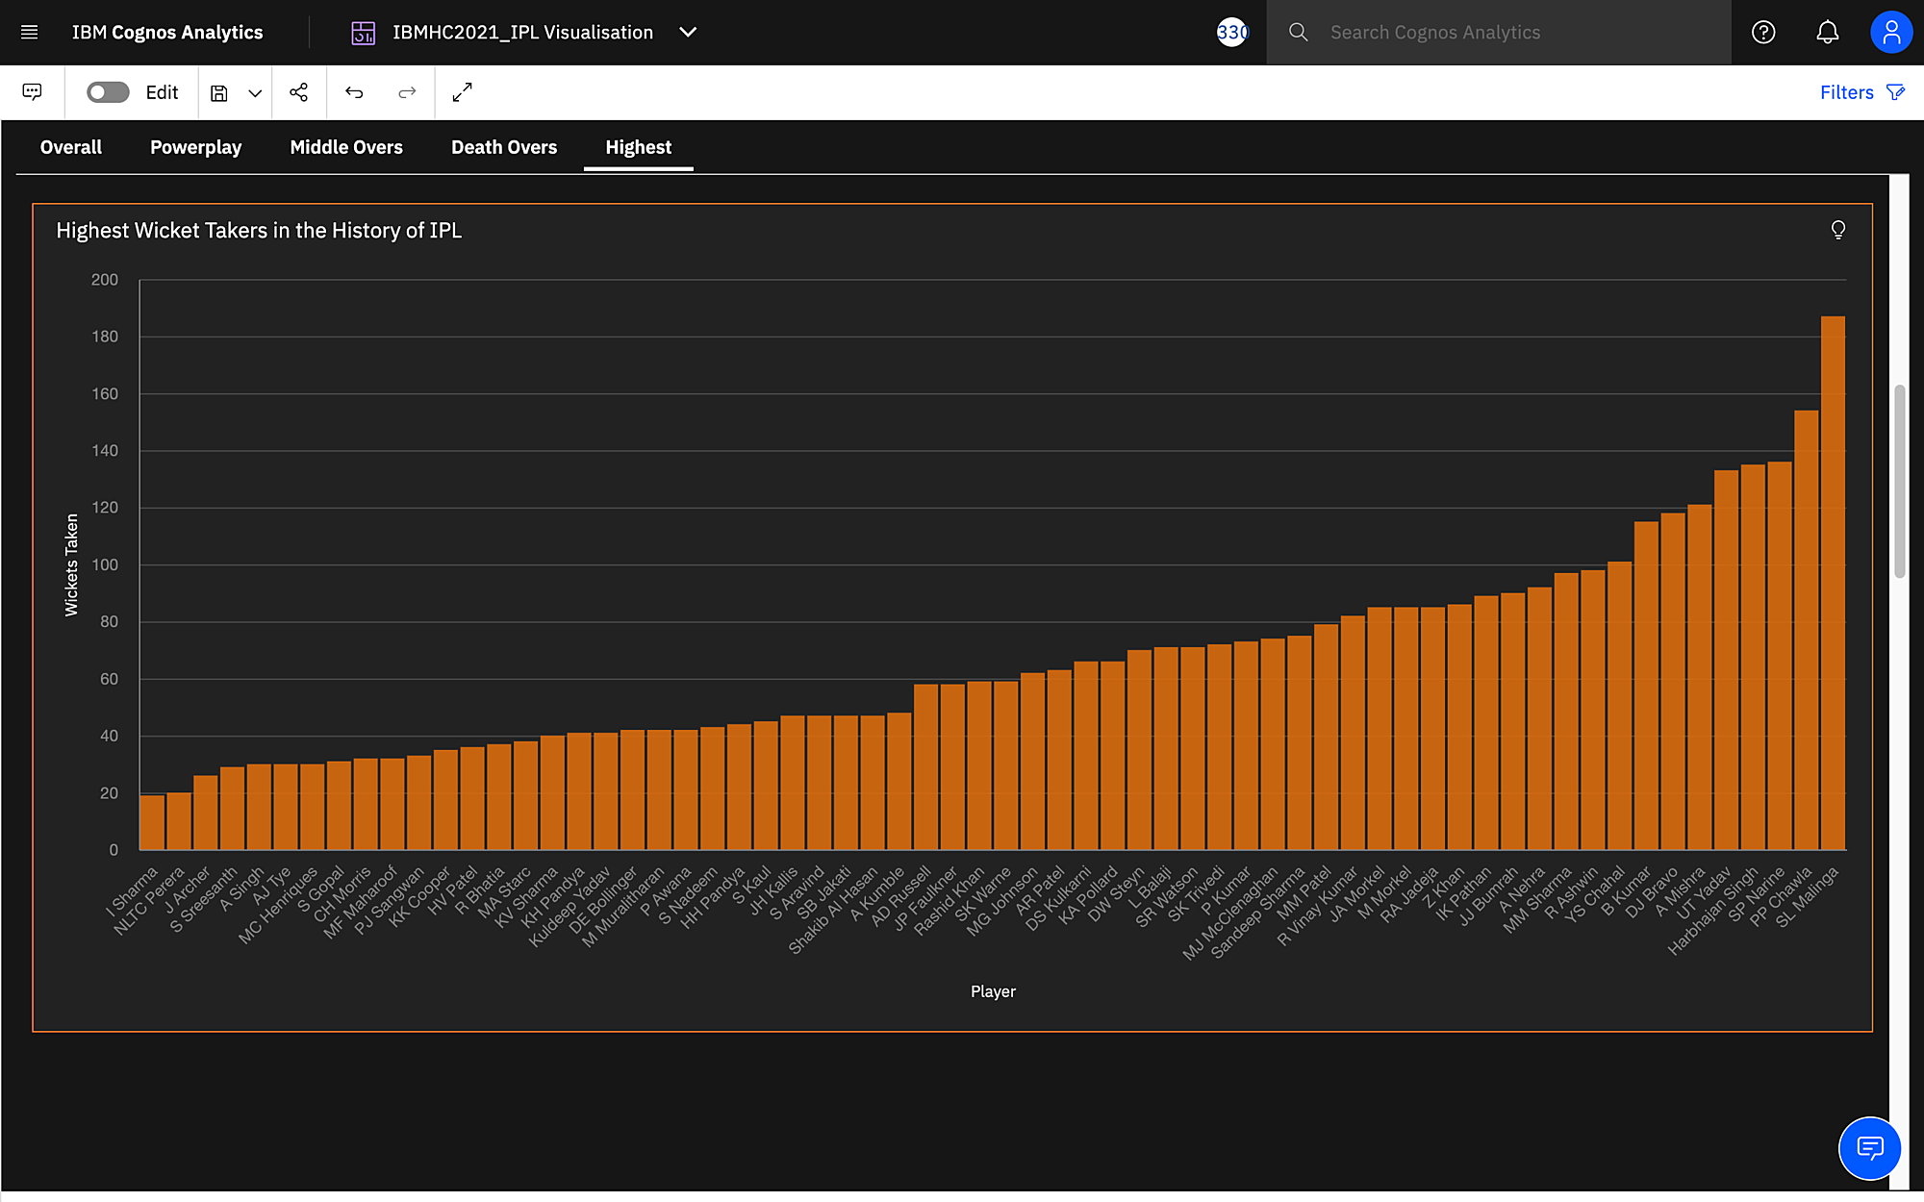

**7. ADVANTAGES AND DISADVANTAGES**

# ADVANTAGES:

# The analyser visualizes the strengths and weaknesses of the team and analyzes important aspects of the game.

1. In depth analysis of each team yields useful insights which can be used by the team management, competitors and common public to make efficient decisions about game.
2. The analysis is performed on the different phases of game with top and week performers in each phase of the team.
3. The analysis concentrates on area of weakness to highlight the week link of the team.
4. The predictor helps in predicting the average score which will help in better planning by the team management and competitors.
5. Overall analysis is performed to understand the nature of tournament and its history over the past.
6. Minimal queries can be resolved using the chatbot feature which will provide basic information about the tournament.

# DISADVANTAGES

In any product, pros and cons are inadvertently present. The efficiency of the product is decided by magnitude of each. The efficiency can be increased by increasing the pros of the product.

Some cons are:

1. Critical decision making is not supported as the results yielded by the product are not conclusive and concrete.
2. In depth analysis on players are not present as a result of which deploying a game plan for a particular player is difficult.
3. Field placements and nature of pitch cannot be decided based on the results yielded by the product.

The above cons can be resolved and those features can be incorporated in future.

**8. APPLICATIONS**

The IPL predictor visualises useful insights and predicts outputs for instances provided by the user. The product caters to the needs of sports analysts, broadcasters, sports enthusiasts, business corporates, team management and so on. The usage of the project among various target audiences are briefed below:

**1. Sports analyst:**

Sports analysts are an integral part of any team. Their work is to analyse the strengths and weaknesses of the opponent team so that they can strategize an efficient plan to counter attack the opponents.

The proposed solution will help the analyst to find out the following information:

* The weakness of batsmen so that they can deploy an effective strategy to be deployed in the power plays.
* The bankable players of the opponent team
* Predicting the average score that would help them to plan their batting approach
* Analysing the threat bowlers of the opponent team
* Run rate in the middle overs

The above are some features that will help the analyst to deploy an effective plan

**2. Broadcasters:**

Broadcasters are responsible for presenting the content to the users in a better and informative way. The proposed solution can help the broadcasters to take efficient business decisions based on the rivalries analysed from the past. The proposed work helps the broadcasters to provide insights to the user and also estimate the viewership for a match based on the rivalry.

**3. Sports enthusiasts**

In India, Cricket has reached a status where every household has fans supporting their favourite stars and teams. There are various betting websites where the best playing eleven’s are awarded with rewards. The user can use the useful insights provided by the proposed work to make predictions. In addition, the user can explore more about the team and their opponents.

**4. Business cooperatives:**

Many business cooperatives thrive during the IPL season by deploying projects that will involve a large community of users benefiting both the developers and the users. By analysing various aspects and finding out rivalries in the tournament, they can increase/decrease their money pool. Bigger the rivalry more is the participation in the contest which will lead to a larger profit. The works of the project can be used to plan the contests by analysing rivalries, star players and so on.

**5. Team management**

The players in IPL are chosen on contract basis who are selected through auctions conducted by BCCI. The works of proposed solution will help the management to find the best suited player who will help in filling the voids present in the team. The voids are detected by finding the minimum run rate in the three phases, leakage of runs by the bowlers and so on.

The above are various work cases of our project catering to the social and business impacts.

**9. CONCLUSION**

The project aims at analyzing the IPL dataset which has the history of 10 years IPL data. A dashboard is created using Cognos analytics, to visualize the team performance and comparative analysis. The user can get the desired information of a particular team by inputting the team’s name and the year.

Apart from visualizations, a model is created to predict the first innings score. This is done using Machine learning to give out the best accuracy. An interactive AI chatbot is built which serves as a IPL guide for beginners.

The application is deployed so that the IPL followers can make the best use of it and can make decisions on the team performance to predict the winning team.

**10. FUTURE SCOPE**

Most of the disadvantages stated can be incorporated as a feature in the product. To state a few

1. In depth analysis of each player can be done. The data for this purpose can be scrapped from websites like Cricbuzz, Espn an add the relevant columns to the existing dataset.
2. Pitch conditions can be analysed based on weather conditions and previous match records
3. Game Plan for a particular player with field placements can be analysed.

In future the product can be released as a commercial product without any monetary expectations as a result of which the common public too can have access to the product.

**11. BIBILIOGRAPHY**

1. Python for Everybody: Exploring Data in Python 3 by Dr. Charles Russell Severance:2016
2. Introduction to Machine Learning with Python: A Guide for Data Scientists:2016
3. https://thecleverprogrammer.com/2020/09/23/analyze-ipl-with-python/
4. https://github.com/anujvyas/IPL-First-Innings-Score-Prediction-Deployment
5. https://vincentgarreau.com/particles.js/
6. http://ictactjournals.in/paper/IJSC_Vol_11_Iss_1_Paper_2_2199_2204.pdf

**APPENDIX**

**A. SOURCE CODE**

**Prediction**

**# Linear Regression Model**

from sklearn.linear_model import LinearRegression

model=LinearRegression()

model.fit(X_train,y_train)

y_pred=model.predict(X_test)

from sklearn import metrics

print(metrics.explained_variance_score(y_test,y_pred))

**# Random Forest Regression Model**

from sklearn.ensemble import RandomForestRegressor

model=RandomForestRegressor(n_estimators=200,random_state=0)

model.fit(X_train,y_train)

y_pred=model.predict(X_test)

from sklearn import metrics

print(metrics.explained_variance_score(y_test,y_pred))

**Analysis**

import os, types

import pandas as pd

from botocore.client import Config

import ibm_boto3

def __iter__(self): return 0

# @hidden_cell

# The following code accesses a file in your IBM Cloud Object Storage. It includes your credentials.

# You might want to remove those credentials before you share the notebook.

if os.environ.get('RUNTIME_ENV_LOCATION_TYPE') == 'external':

endpoint_e161d40bff6e4cd0bcddc04f6bf63856 = 'https://s3.eu.cloud-object-storage.appdomain.cloud'

else:

endpoint_e161d40bff6e4cd0bcddc04f6bf63856 = 'https://s3.private.eu.cloud-object-storage.appdomain.cloud'

client_e161d40bff6e4cd0bcddc04f6bf63856 = ibm_boto3.client(service_name='s3',

ibm_api_key_id='',

ibm_auth_endpoint="https://iam.cloud.ibm.com/oidc/token",

config=Config(signature_version='oauth'),

endpoint_url=endpoint_e161d40bff6e4cd0bcddc04f6bf63856)

body = client_e161d40bff6e4cd0bcddc04f6bf63856.get_object(Bucket='',Key='matches.csv')['Body']

# add missing __iter__ method, so pandas accepts body as file-like object

if not hasattr(body, "__iter__"): body.__iter__ = types.MethodType( __iter__, body )

# @hidden_cell

# The project token is an authorization token that is used to access project resources like data sources, connections, and used by platform APIs.

# For exporting dataframes into CSV files

from project_lib import Project

project = Project(project_id='', project_access_token='')

pc = project.project_context

matches= pd.read_csv(body)

matches.head()

teams_with_most_number_of_wins=matches.winner.mode()

teams_with_most_number_of_wins

x=matches.groupby('winner')['winner'].count().sort_values(ascending=False)

y=x.index

z=x.values

x = x.reset_index(name="count")

x['count']=x['count'].astype(int)

x=x[0:5]

x

project.save_data(file_name='most_number_of_wins1.csv',data=x.to_csv)

import os, types

import pandas as pd

from botocore.client import Config

import ibm_boto3

def __iter__(self): return 0

# @hidden_cell

# The following code accesses a file in your IBM Cloud Object Storage. It includes your credentials.

# You might want to remove those credentials before you share the notebook.

if os.environ.get('RUNTIME_ENV_LOCATION_TYPE') == 'external':

endpoint_e161d40bff6e4cd0bcddc04f6bf63856 = 'https://s3.eu.cloud-object-storage.appdomain.cloud'

else:

endpoint_e161d40bff6e4cd0bcddc04f6bf63856 = 'https://s3.private.eu.cloud-object-storage.appdomain.cloud'

client_e161d40bff6e4cd0bcddc04f6bf63856 = ibm_boto3.client(service_name='s3',

ibm_api_key_id='',

ibm_auth_endpoint="https://iam.cloud.ibm.com/oidc/token",

config=Config(signature_version='oauth'),

endpoint_url=endpoint_e161d40bff6e4cd0bcddc04f6bf63856)

body = client_e161d40bff6e4cd0bcddc04f6bf63856.get_object(Bucket='',Key='deliveries.csv')['Body']

# add missing __iter__ method, so pandas accepts body as file-like object

if not hasattr(body, "__iter__"): body.__iter__ = types.MethodType( __iter__, body )

team=pd.read_csv(body)

team.head(1000)

def powerplay(teamName):

runs=0;

match=0;

matchid=0;

for i in range(0,len(team)):

if(team['batting_team'][i] ==teamName):

if(team['over'][i]<=6 and team['inning'][i]==1):

runs+=team['total_runs'][i];

if(matchid!=team['match_id'][i]):

matchid=team['match_id'][i];

match+=1;

if(team['bowling_team'][i] ==teamName):

if(team['over'][i]<=6 and team['inning'][i]==2):

runs+=team['total_runs'][i];

if(matchid!=team['match_id'][i]):

matchid=team['match_id'][i];

match+=1;

Average=runs/match

powerplay=Average/6

return [teamName,runs,match,Average,powerplay]

powerplay_csk=powerplay("Chennai Super Kings")

powerplay_dd=powerplay("Delhi Daredevils")

powerplay_kkr=powerplay("Kolkata Knight Riders")

powerplay_kxip=powerplay("Kings XI Punjab")

powerplay_mi=powerplay("Mumbai Indians")

powerplay_rcb=powerplay("Royal Challengers Bangalore")

powerplay_rr=powerplay("Rajasthan Royals")

powerplay_srh=powerplay("Sunrisers Hyderabad")

powerplay_teams=[powerplay_csk,powerplay_dd,powerplay_kkr,powerplay_kxip,powerplay_mi,powerplay_rcb,powerplay_rr,powerplay_srh]

# print(powerplay_teams)

powerplay_stats=pd.DataFrame(powerplay_teams,columns=['TeamName', 'RunsInPP','MatchesPlayed','AvgPPScore','RunRateInPP'])

powerplay_stats.head(8)

project.save_data(file_name='powerplay_stats.csv',data=powerplay_stats.to_csv())

**For more source code, refer to the following GitHub link:**

[Deliverables](https://github.com/smartinternz02/SBSPS-Challenge-5351-Super-Predictor-of-Indian-Premier-League-IPL-)

**For video demonstration, refer to the following YouTube link:**

[Video Demonstration](https://www.youtube.com/watch?v=il1TlBY_K0Y)